# VISVESVARAYA TECHNOLOGICAL UNIVERSITY

**“JnanaSangama”, Belgaum -590014, Karnataka.**



**LAB RECORD**

**Computer Network Lab (23CS5PCCON)**

### Submitted by

**MAKADIA RISHIT DILIPBHAI (1BM23CS177)**

### in partial fulfillment for the award of the degree of

**BACHELOR OF ENGINEERING**

***in***

**COMPUTER SCIENCE AND ENGINEERING**



## B.M.S. COLLEGE OF ENGINEERING

**(Autonomous Institution under VTU)**

## BENGALURU-560019

**September 2025 – January 2026**

**B. M. S. College of Engineering,**

**Bull Temple Road, Bangalore 560019**

(Affiliated To Visvesvaraya Technological University, Belgaum)

**Department of Computer Science and Engineering**



**CERTIFICATE**

This is to certify that the Lab work entitled “Computer Network (23CS5PCCON)” carried out by **MAKADIA RISHIT DILIPBHAI (1BM23CS177),** who is bonafide student of **B.M.S. College of Engineering.** It is in partial fulfilment for the award of **Bachelor of Engineering in Computer Science and Engineering** of the Visvesvaraya Technological University, Belgaum. The Lab report has been approved as it satisfies the academic requirements of the above-mentioned subject and the work prescribed for the said degree.

| Praveen N.  Assistant Professor  Department of CSE, BMSCE | Dr. Kavitha Sooda Professor & HOD  Department of CSE, BMSCE |
| --- | --- |

# Index

| **Sl.**  **No.** | **Date** | **Experiment Title** | **Page No.** |
| --- | --- | --- | --- |
| 1 | 9/9/25 | Configure DHCP within a LAN and outside LAN. | 1 |
| 2 | 9/9/25 | Configure Web Server, DNS within a LAN. | 3 |
| 3 | 18/11/25 | To understand the operation of TELNET | 5 |
| 4 | 9/9/25 | Configure IP address to routers in packet tracer. Explore messages: | 7 |
| 5 | 23/9/25 | Configure default route, static route to the Router | 9 |
| 6 | 23/9/25 | Configure RIP routing Protocol in Routers | 11 |
| 7 | 14/10/25 | Configure OSPF routing protocol | 13 |
| 8 | 11/11/25 | Demonstrate the TTL/ Life of a Packet | 14 |
| 9 | 14/10/25 | To construct a VLAN and make the PC’s communicate among a VLAN | 16 |
| 10 | 11/11/25 | To construct a WLAN and make the nodes communicate wirelessly | 18 |
| 11 | 18/11/25 | To understand the concept and operation of Address Resolution Protocol (ARP) | 19 |
| 12 | 19/8/25 | Create a topology and simulate sending a simple PDU using Hub and Switch | 21 |
| 14 | 28/10/25 | Congestion control using Leaky bucket algorithm. | 22 |
| 15 | 28/10/25 | Using TCP/IP sockets, write a client-server program | 24 |
| 16 | 28/10/25 | Using UDP sockets, write a client-server program | 25 |
| 17 | 28/10/25 | Error detecting code using CRC-CCITT | 26 |

Github Link:

<https://github.com/rishitmakadia/1BM23CS177_CON_5>

**Program – 1:  
  
Aim:** Configure DHCP within a LAN and outside LAN.  
**Topology:**

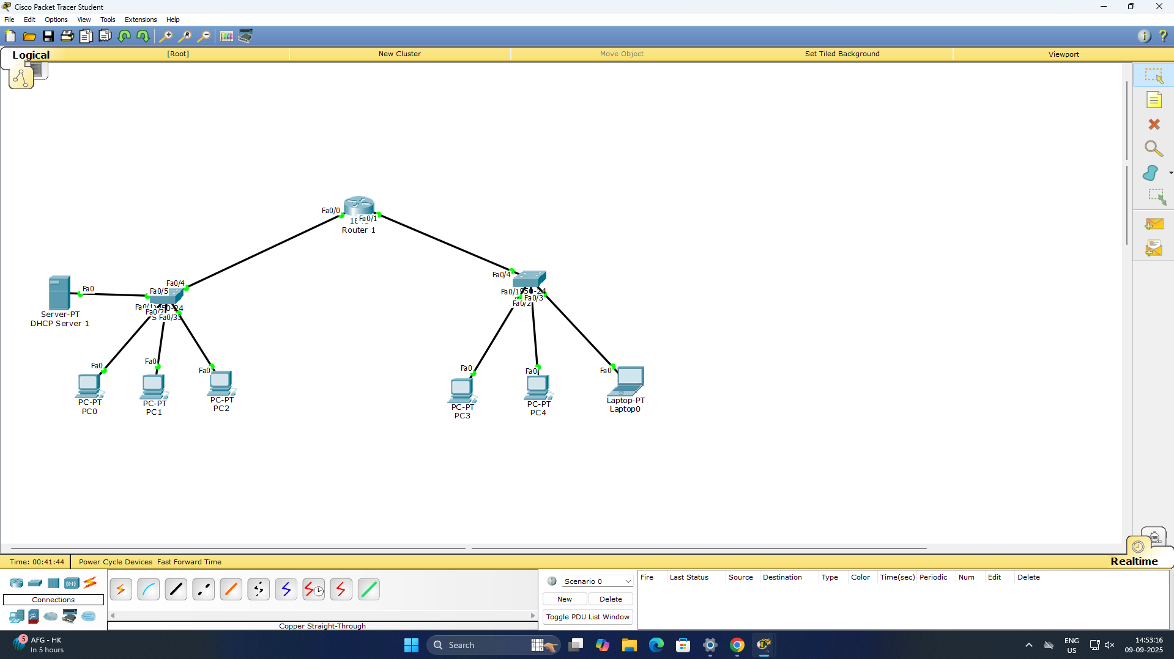

**Procedure:**

1. Configure DHCP Server:  
   in DHCP server go to Desktop>IP-Config, assign static IP – 192.168.10.2 and gateway 192.168.10.1
2. Open Services>DHCP and add following two dhcp pool:
3. Pool Name: switch1

Gateway: 192.168.10.1

Start Ip: 192.168.10.3  
Subnet Mask: 255.255.255.0  
Max Users: 20

1. Pool Name: switch2

Gateway: 192.168.20.1

Start Ip: 192.168.10.2  
Subnet Mask: 255.255.255.0  
Max Users: 20

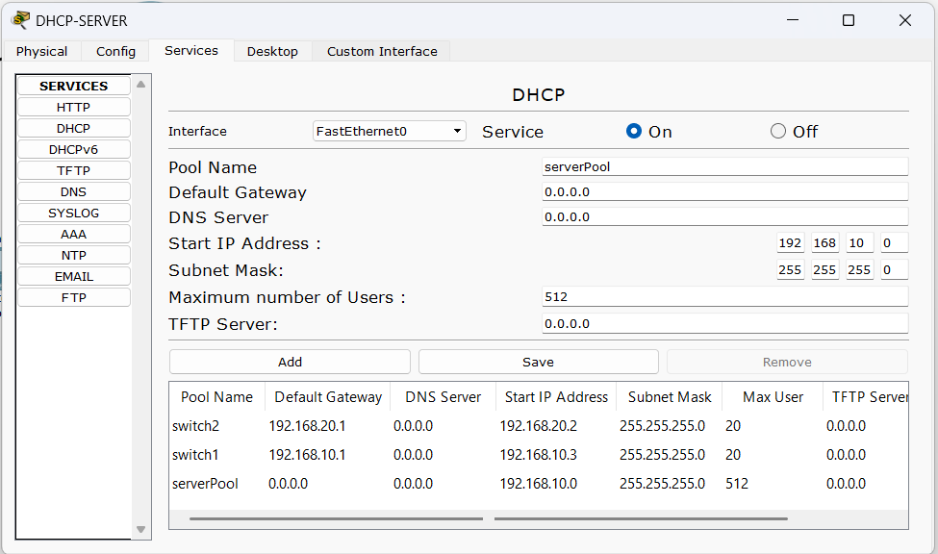

1. Configure Router

Router>enable

Router#configure terminal

Router(config)# int fa0/0

Router(config-if)# ip address 192.168.10.1 255.255.255.0

Router(config-if)# ip helper-address 192.168.10.2

Router(config-if)# no shutdown

Router(config-if)# exit

Router(config)# int fa0/1

Router(config-if)# ip address 192.168.20.1 255.255.255.0

Router(config-if)# ip helper-address 192.168.10.2

Router(config-if)# no shutdown

Router(config-if)# exit

Router(config)# exit

Router# write memory

**Output**

**Observation**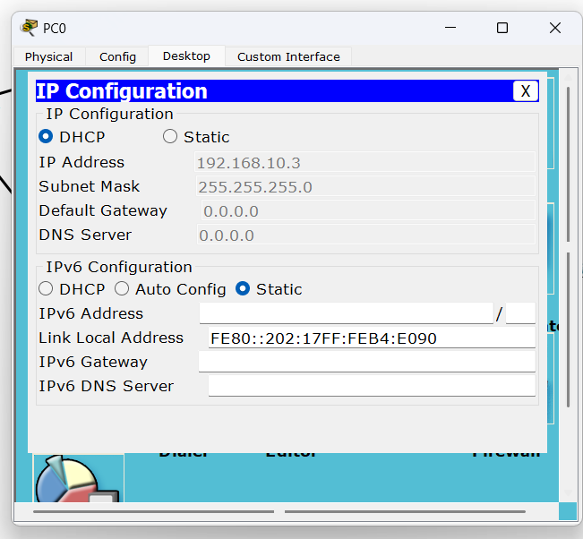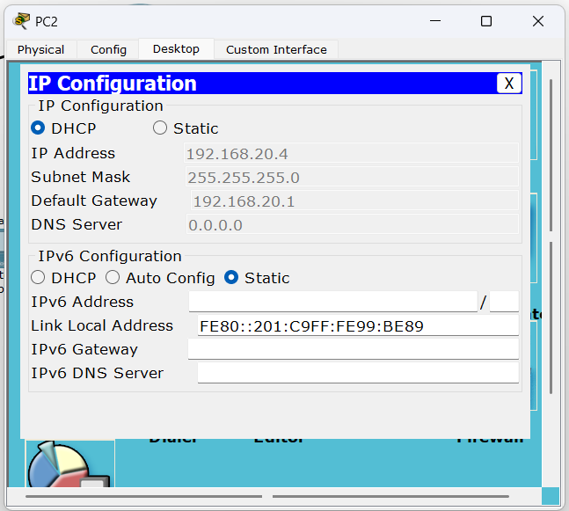

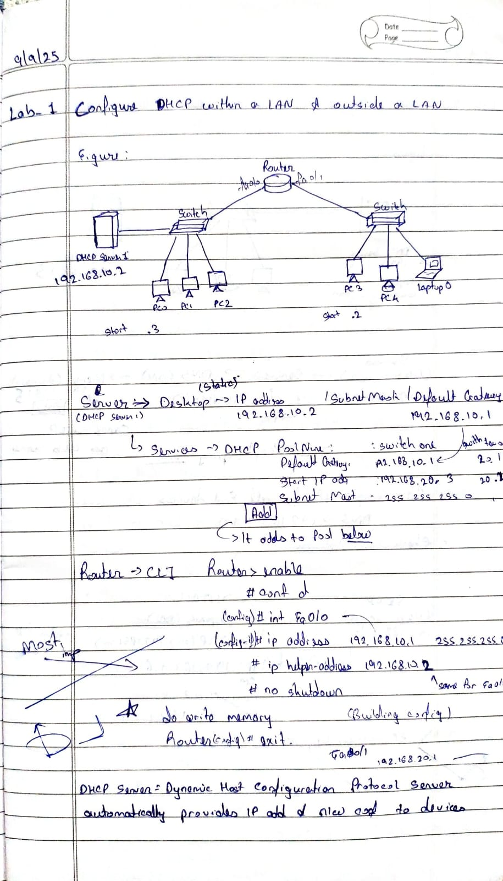

**Program 2**

**Aim:** Configure Web Server, DNS within a LAN.

**Topology:**

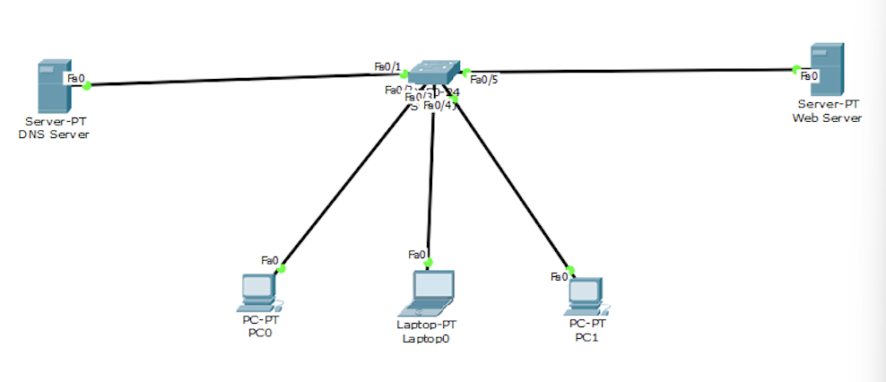

**Procedure:**

#### 1. Configure Server

* Set static IP: 192.168.1.10/24
* Services > DNS: Enable, add A record:  
  www.mysite.com → 192.168.1.10
* Services > HTTP: Enable, add simple HTML page

#### 2. Configure Clients

* Set IP: 192.168.1.x/24
* Set DNS: 192.168.1.10

#### 3. Verification

* Command Prompt: ping www.mysite.com (should resolve to 192.168.1.10)
* Web Browser: Navigate to http://www.mysite.com (should load webpage)

**Output:**

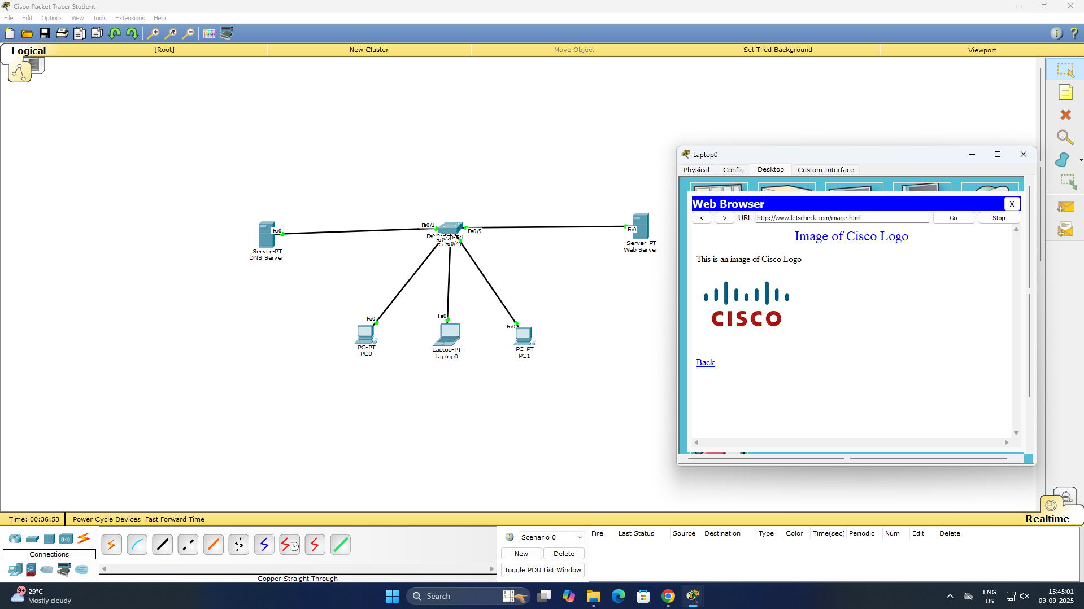

**Observation:**

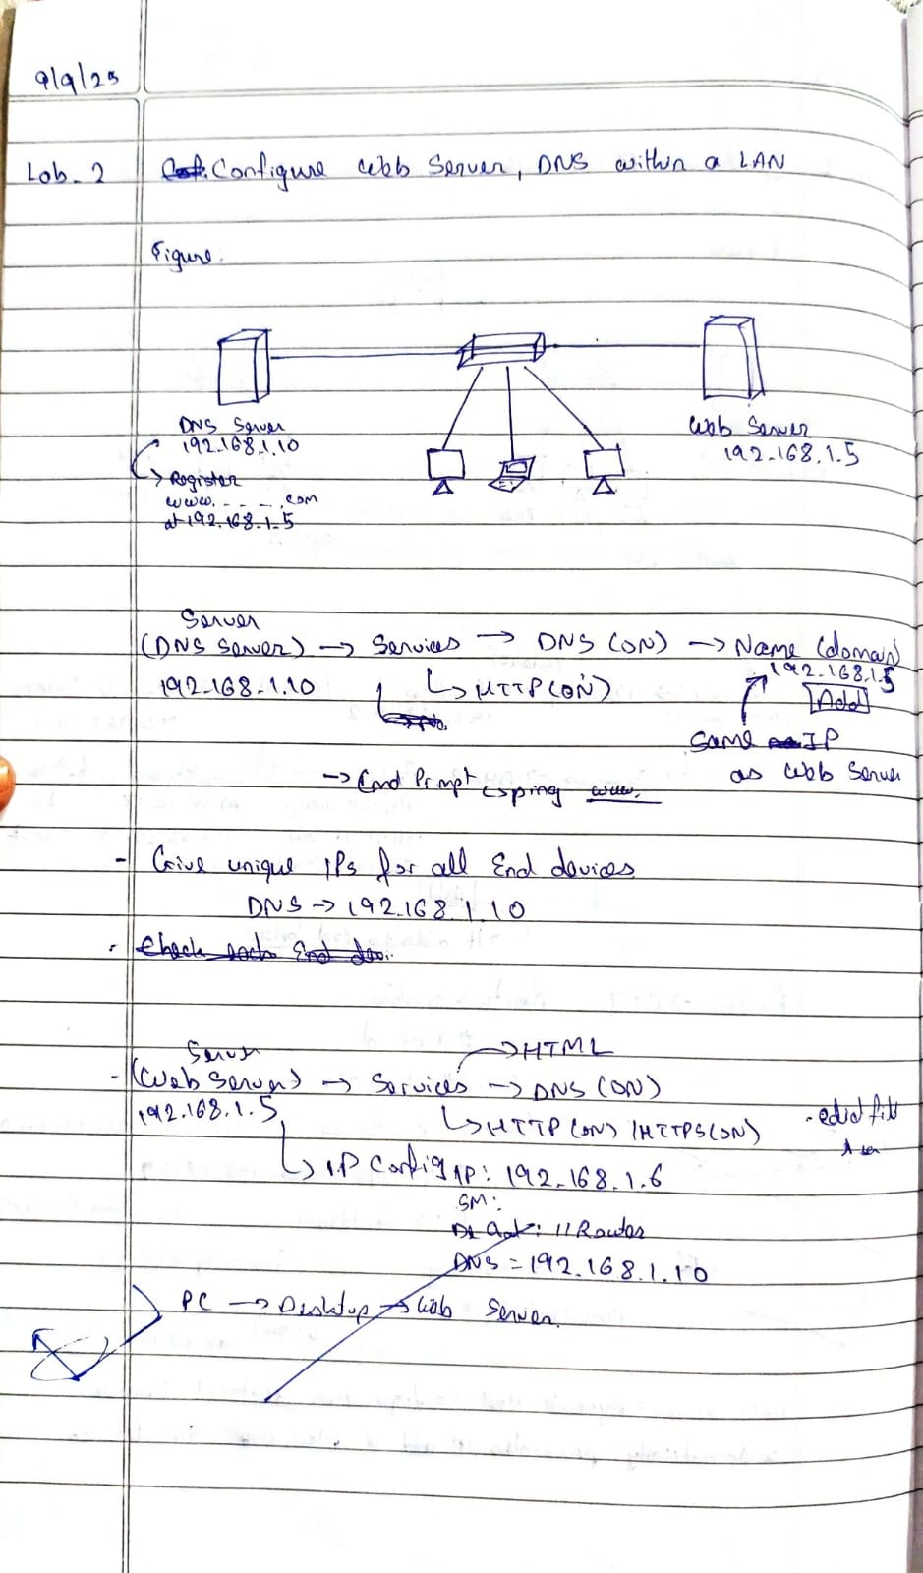

**Program 3**

**Aim:** To understand the operation of TELNET by accessing the router in server room from a PC in IT office.

**Topology:**

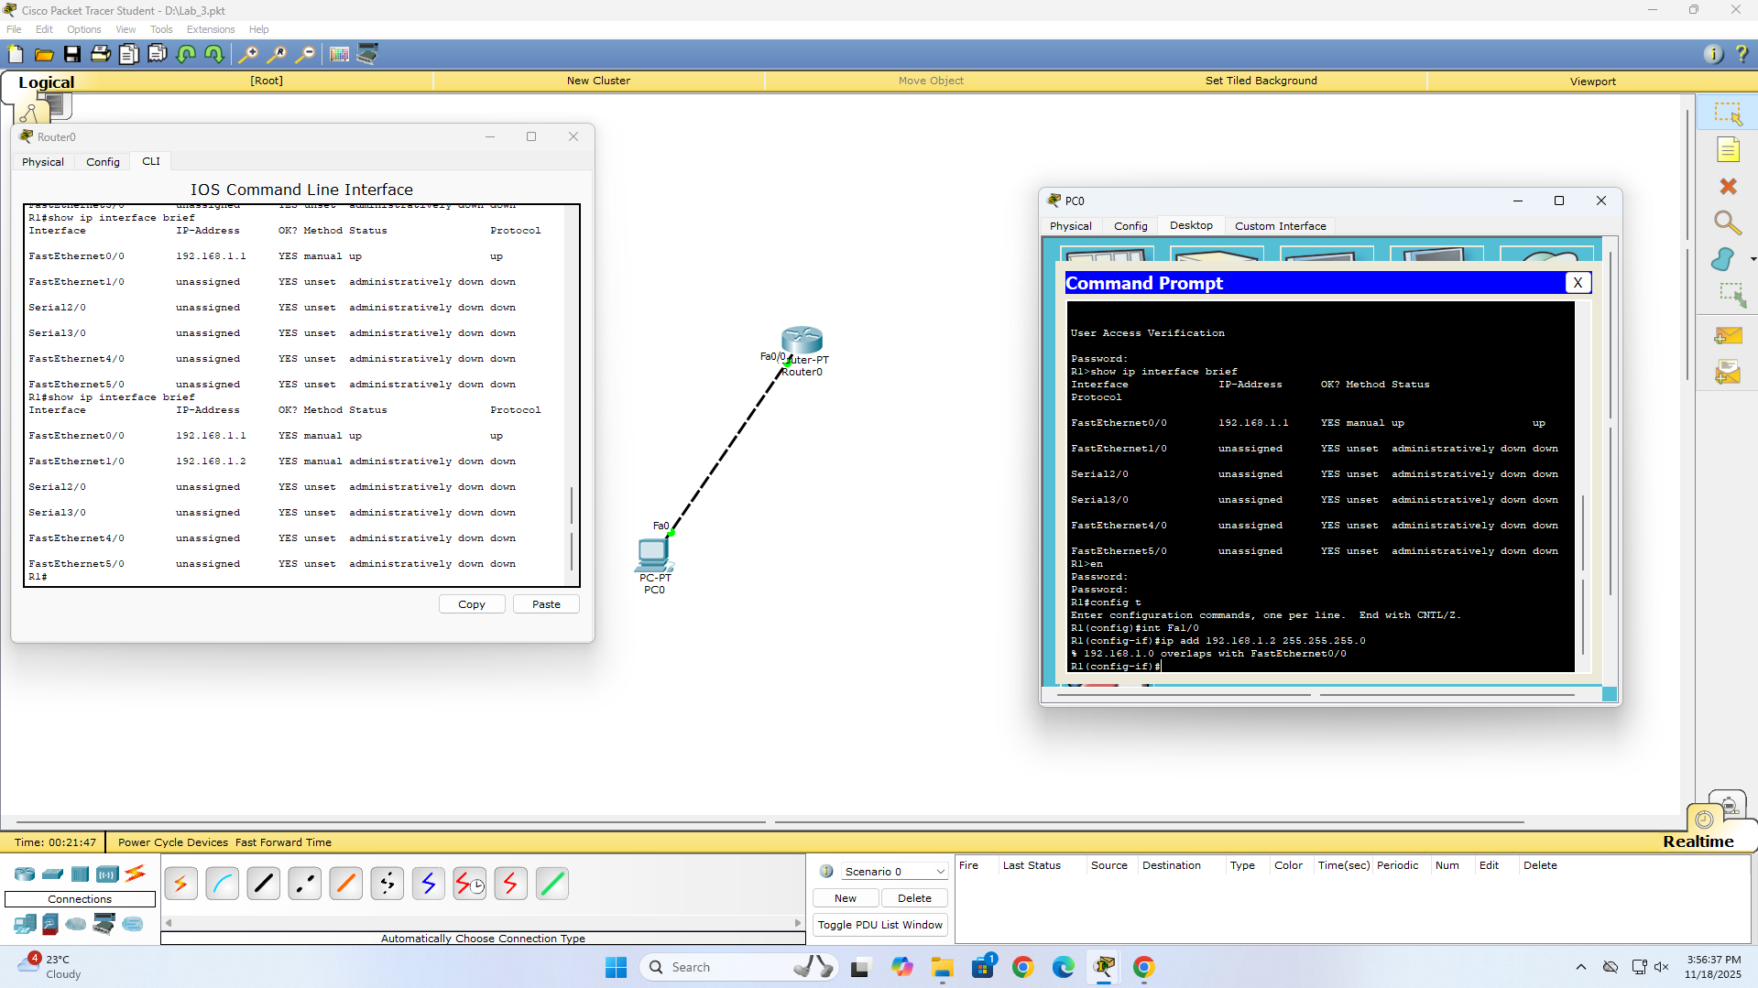

**Procedure:**

#### 1. Configure Router

Router> enable

Router# configure terminal

Router(config)# hostname R1

R1(config)# interface fastethernet 0/0

R1(config-if)# ip address 192.168.1.1 255.255.255.0

R1(config-if)# no shutdown

R1(config-if)# exit

R1(config)# line vty 0 4

R1(config-line)# password tp

R1(config-line)# login

R1(config-line)# exit

R1(config)# enable secret class

R1(config)# exit

R1# write memory

#### 2. Configure PC

* Set static IP: 192.168.1.2/24
* Default gateway: 192.168.1.1

#### 3. Establish TELNET Session

ip: 192.168.1.2

mask: 255.255.255.0

gateway: 192.168.1.1

# Test connectivity

ping 192.168.1.1

telnet 192.168.1.1

# Password: tp

# enable

# Secret: class

**Output:**

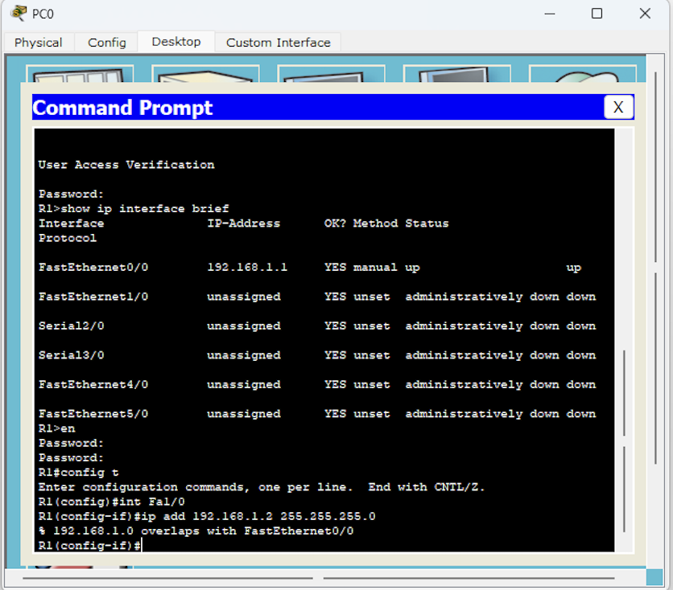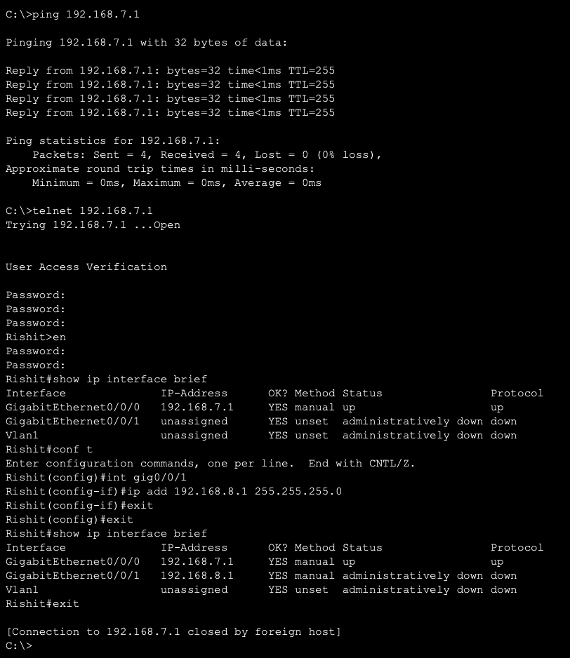

**Observation:**

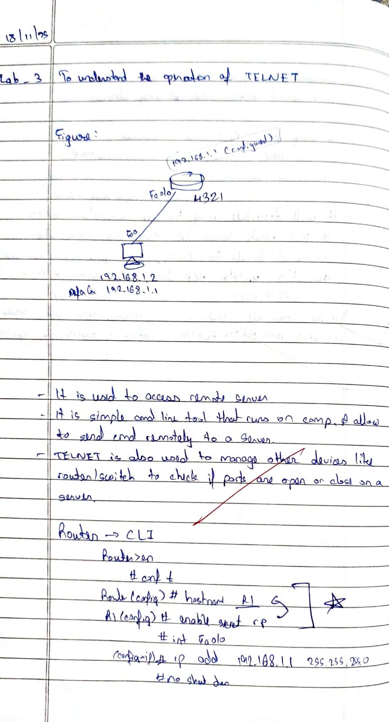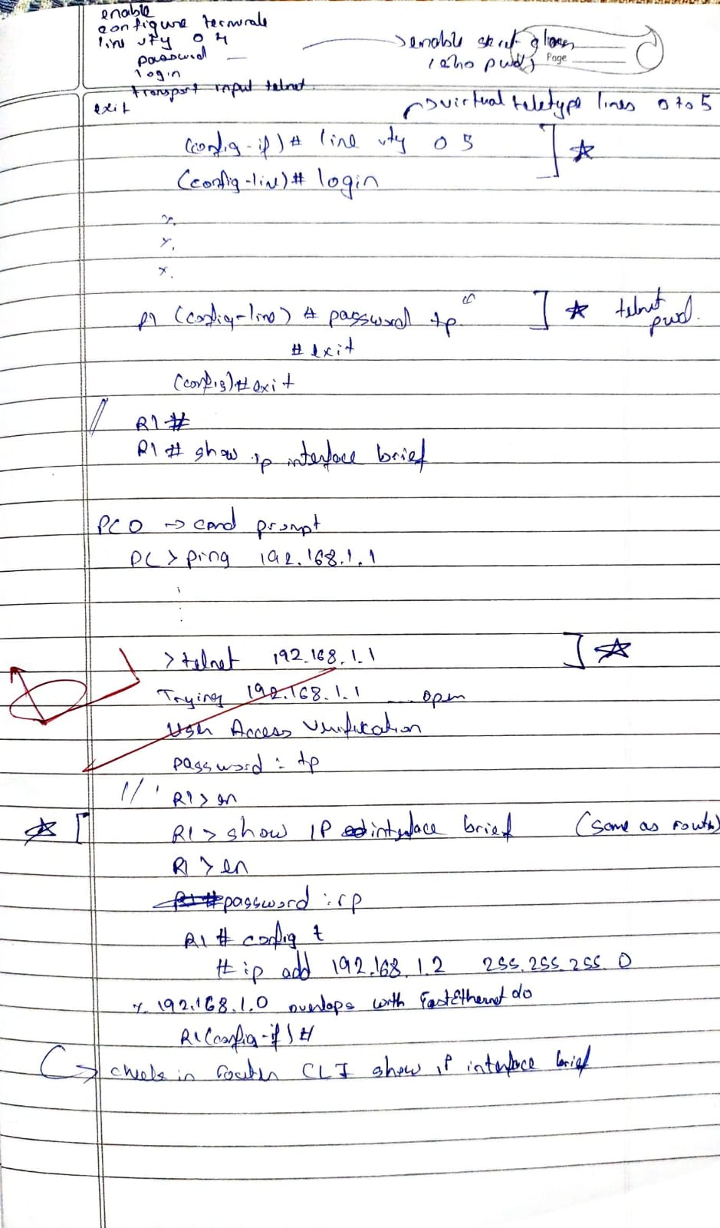

**Program 4**

**Aim:** Configure IP address to routers in packet tracer. Explore the following messages: ping responses, destination unreachable, request timed out, reply

**Topology:**

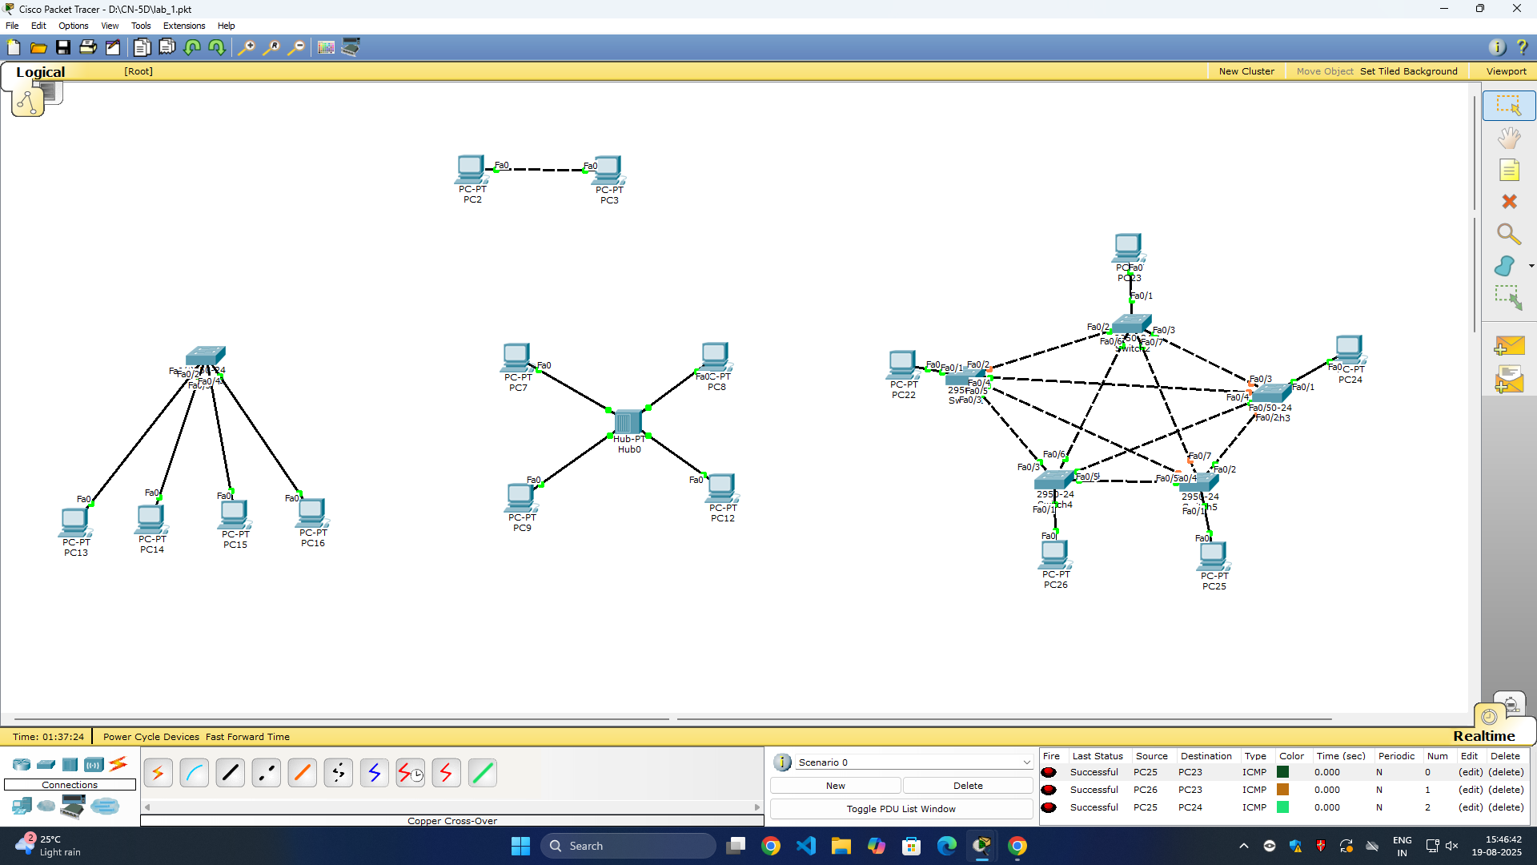

**Output:**

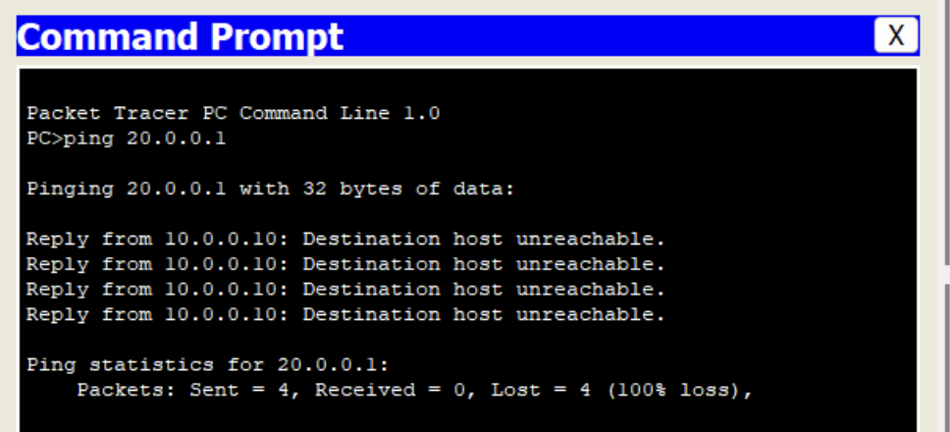

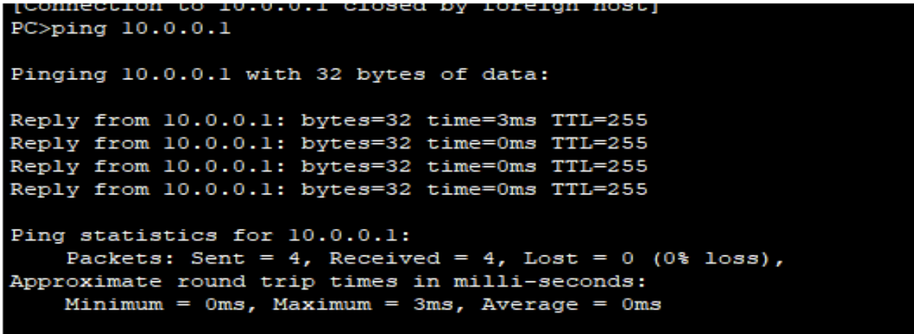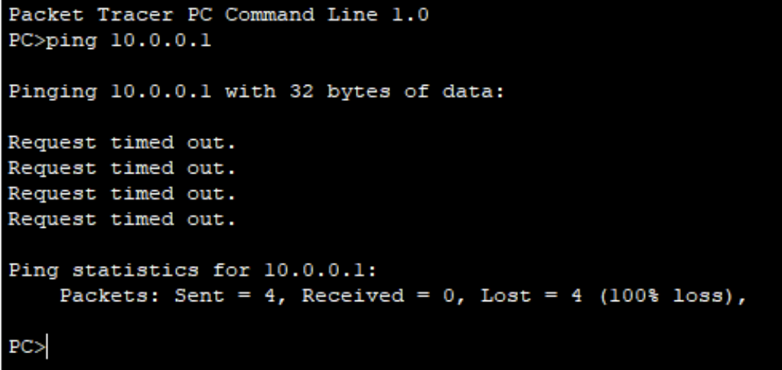

**Observation:**

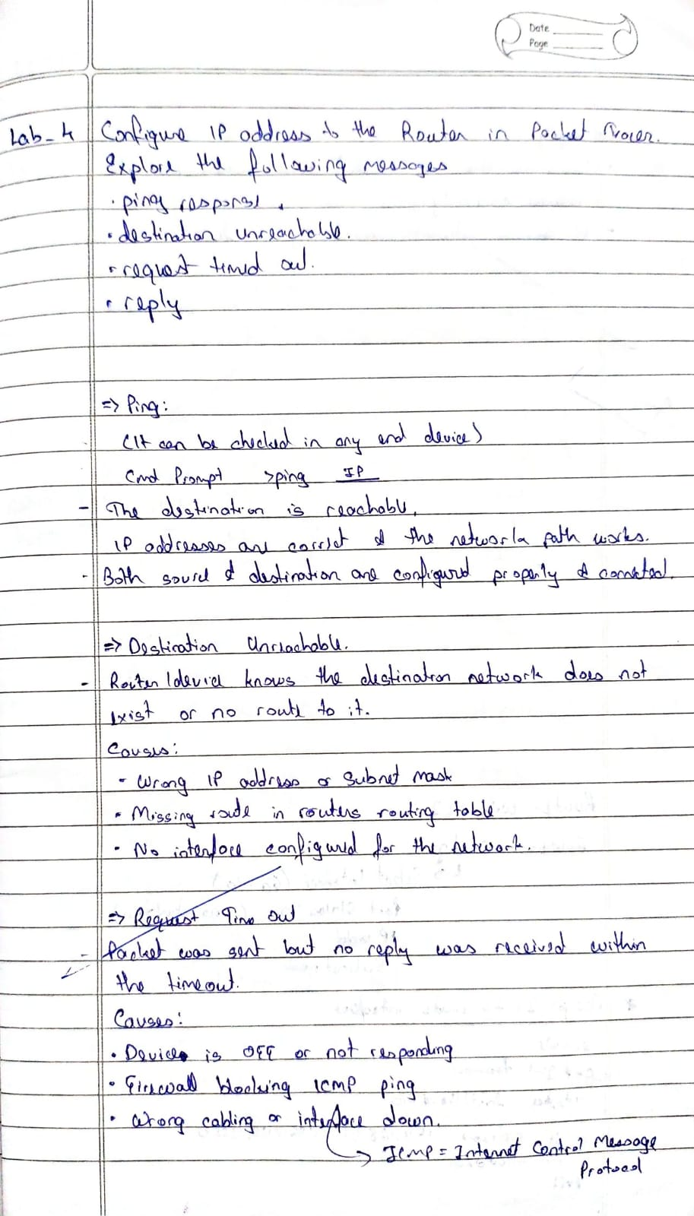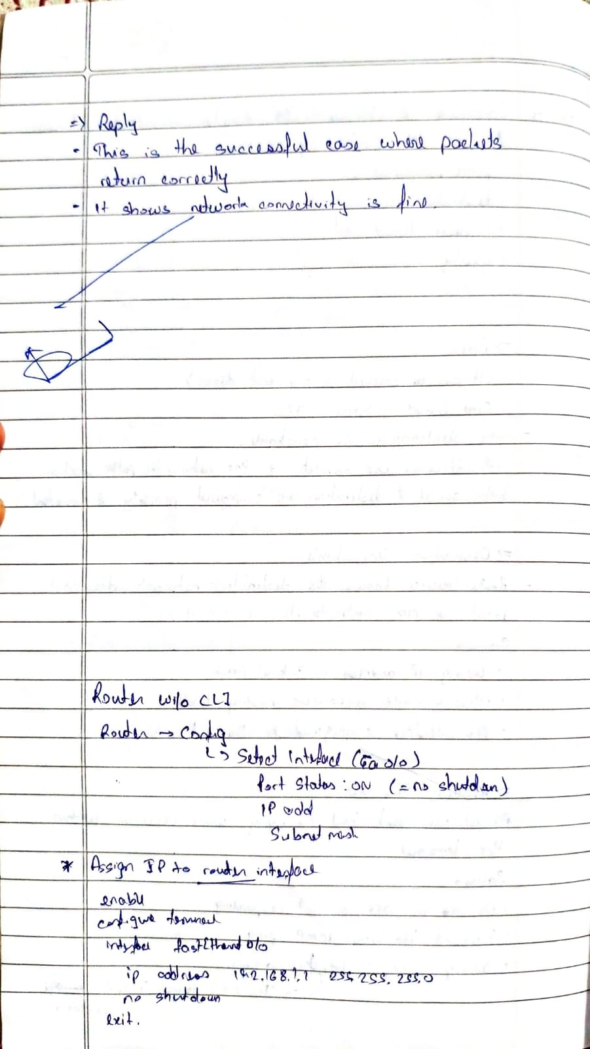

**Program 5**

**Aim:** Configure default route, static route to the Router

**Topology:**

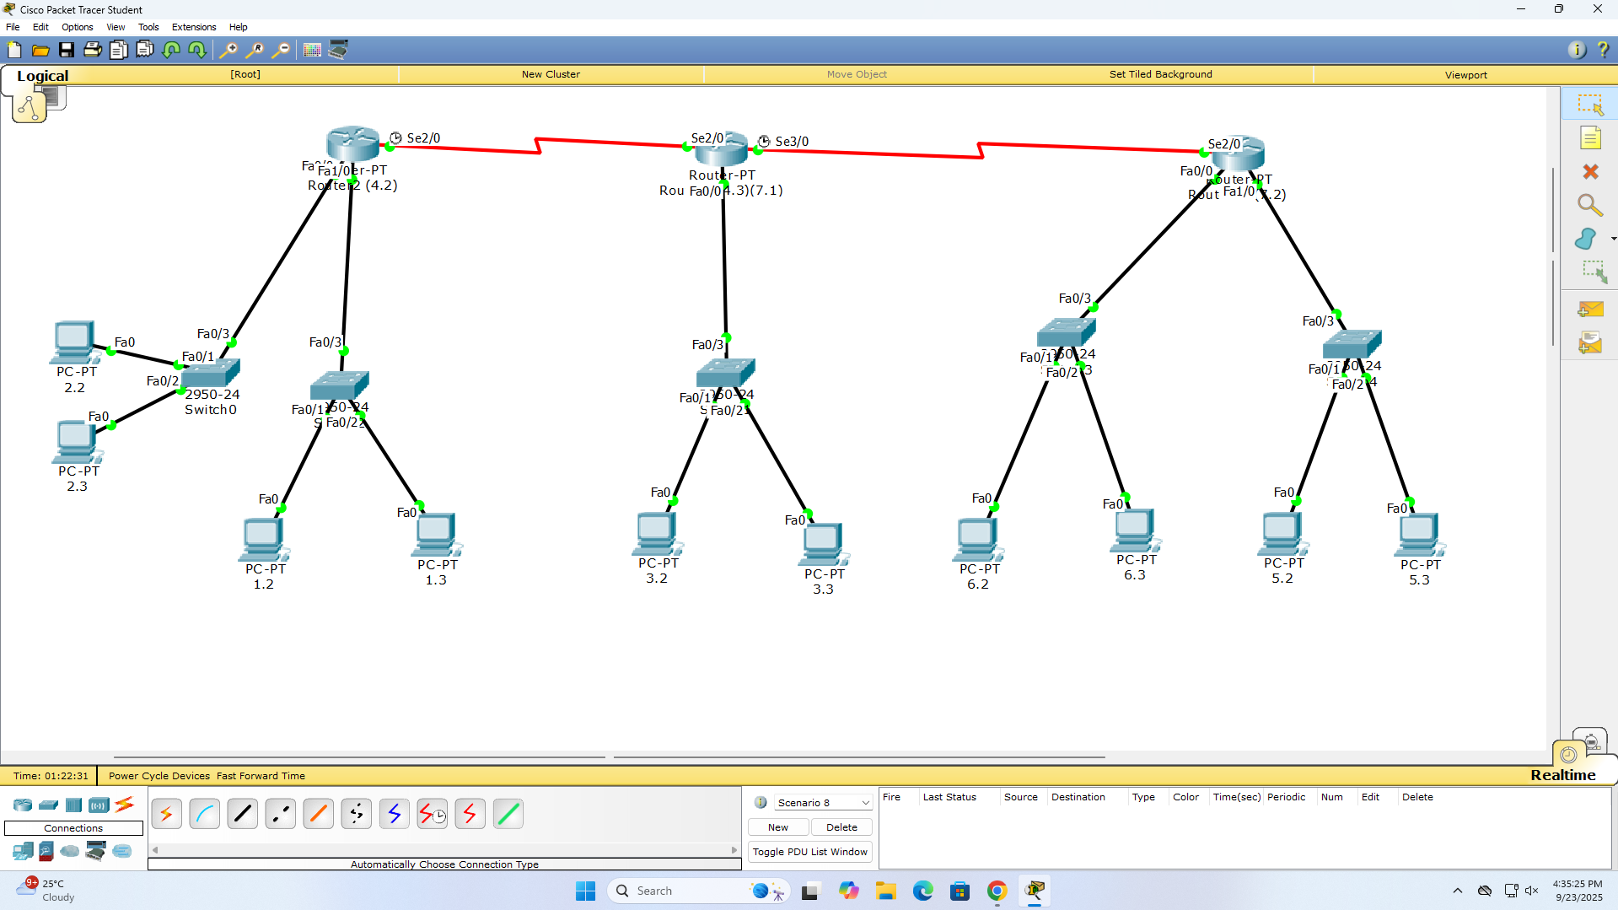

**Procedure:**

Router> enable

Router# configure terminal

Router(config)# hostname Router3

Router3(config)# interface fastethernet 0/0

Router3(config-if)# ip address 192.168.4.1 255.255.255.0

Router3(config-if)# no shutdown

Router3(config-if)# exit

Router3(config)# interface fastethernet 1/0

Router3(config-if)# ip address 192.168.5.1 255.255.255.0

Router3(config-if)# no shutdown

Router3(config-if)# exit

Router3(config)# ip route 192.168.1.0 255.255.255.0 192.168.4.1

Router3(config)# ip route 192.168.2.0 255.255.255.0 192.168.4.1

Router3(config)# ip route 192.168.3.0 255.255.255.0 192.168.4.2

Router3(config)# ip route 192.168.6.0 255.255.255.0 192.168.5.2

# Configure default route (if needed)

Router3(config)# ip route 0.0.0.0 0.0.0.0 192.168.4.1

Router3(config)# exit

Router3# write memory

**Output:**

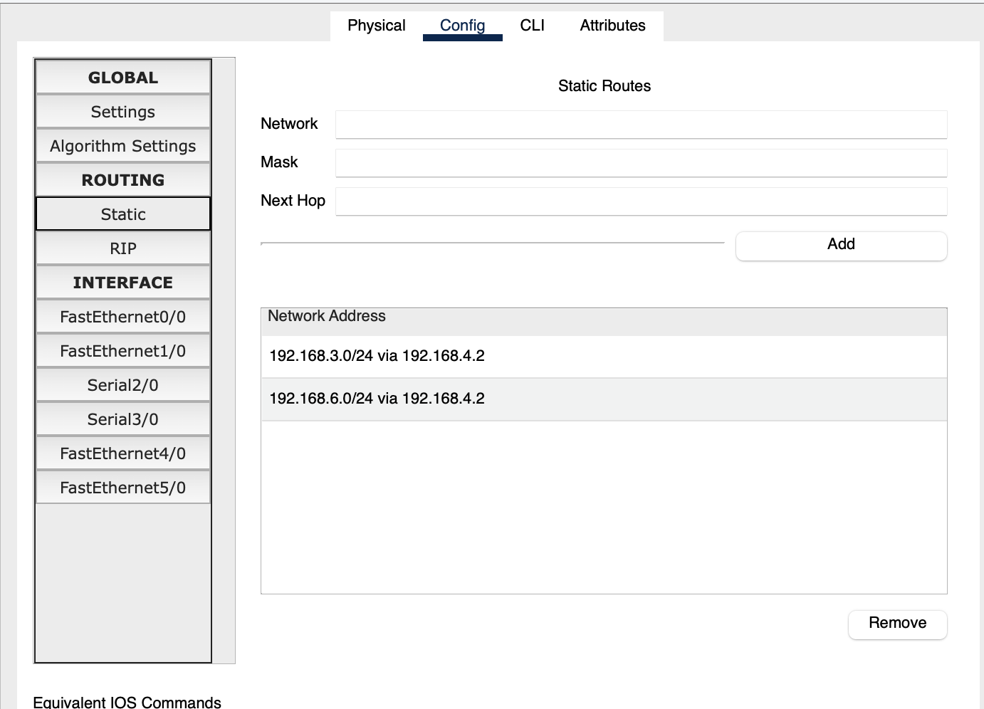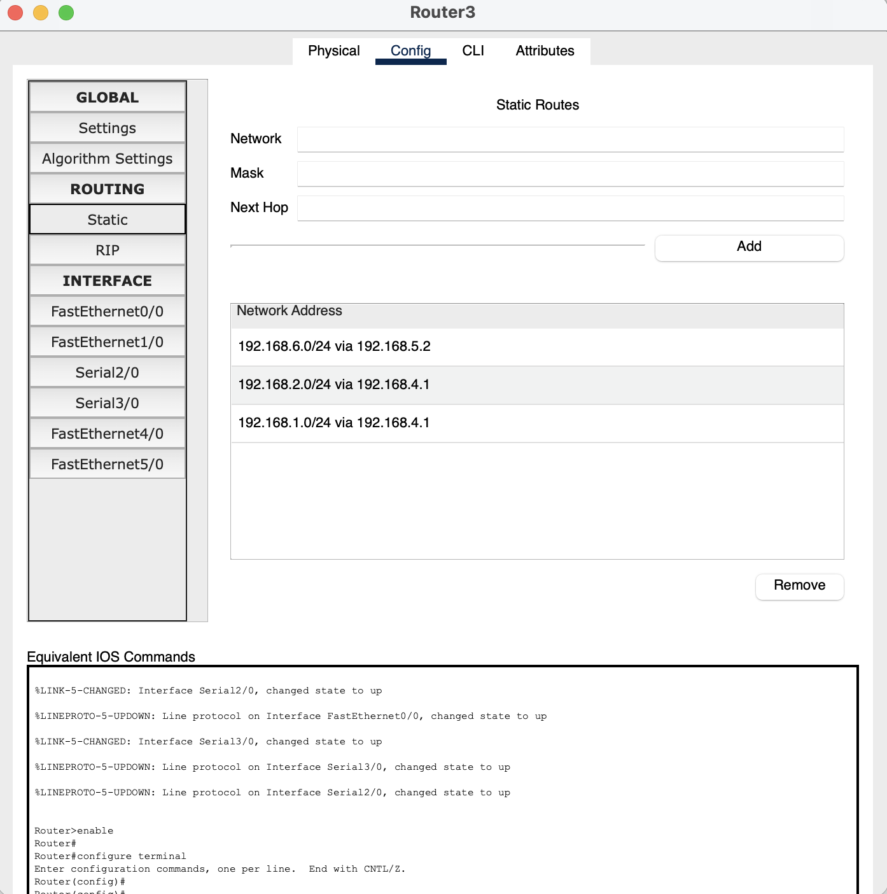

**Observation:**

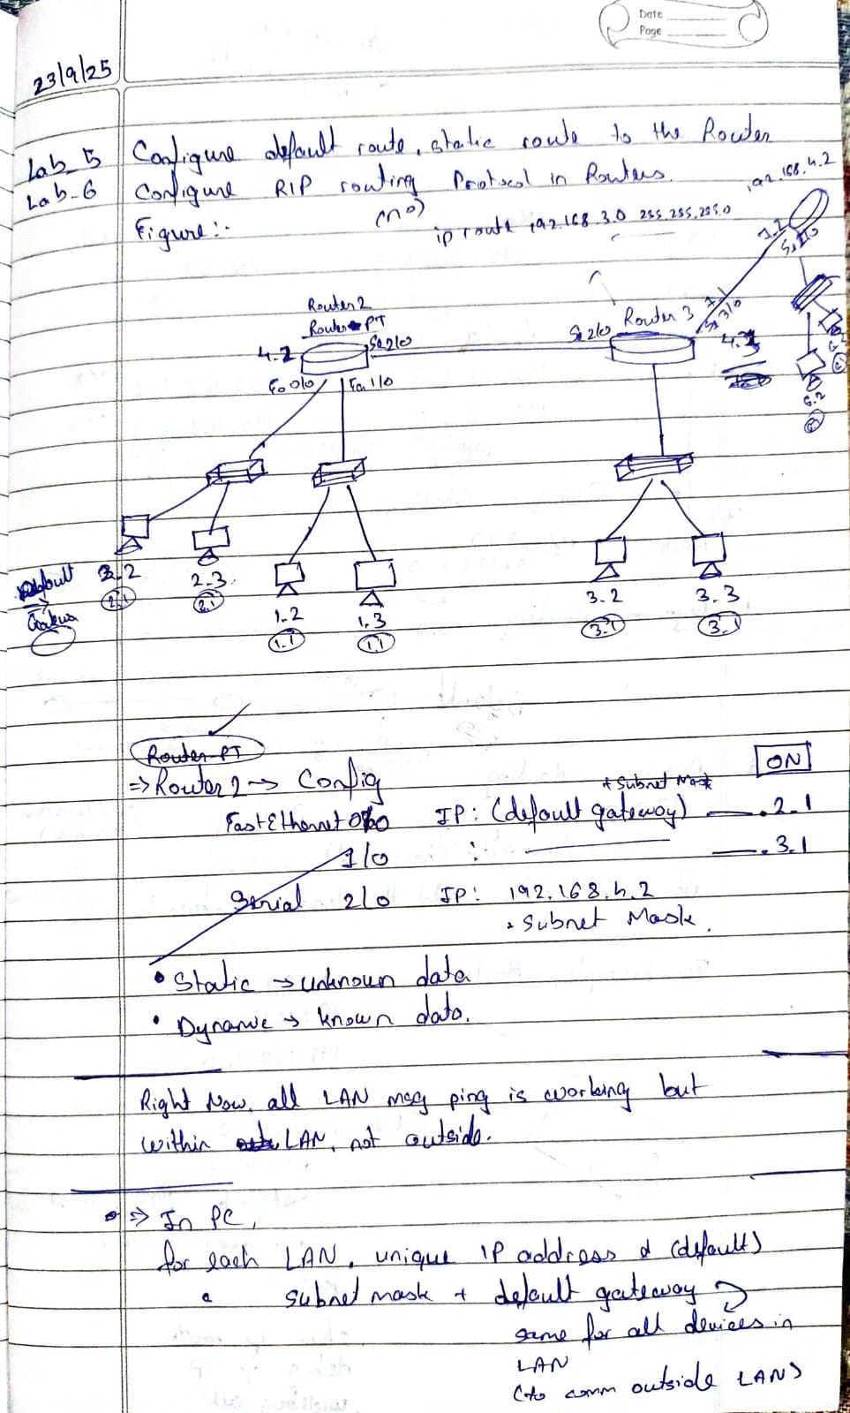

**Program 6**

**Aim:** Configure RIP routing Protocol in Routers

**Topology:**



**Procedure:**

#### 1. Configure Interfaces:

* Go to: Config tab → INTERFACE
* FastEthernet0/0:
  + IP Address: 192.168.3.1
  + Subnet Mask: 255.255.255.0
* FastEthernet1/0:
  + IP Address: 192.168.4.1
  + Subnet Mask: 255.255.255.0
* Serial2/0:
  + IP Address: 192.168.7.1
  + Subnet Mask: 255.255.255.0

#### 2. Configure RIP Routing:

* Go to: Config tab → ROUTING → RIP
* Settings:
  + Version: RIP Version 2
* Network Entries:
  + Click Add → Network: 192.168.3.0
  + Click Add → Network: 192.168.4.0
  + Click Add → Network: 192.168.7.0

**Output:**

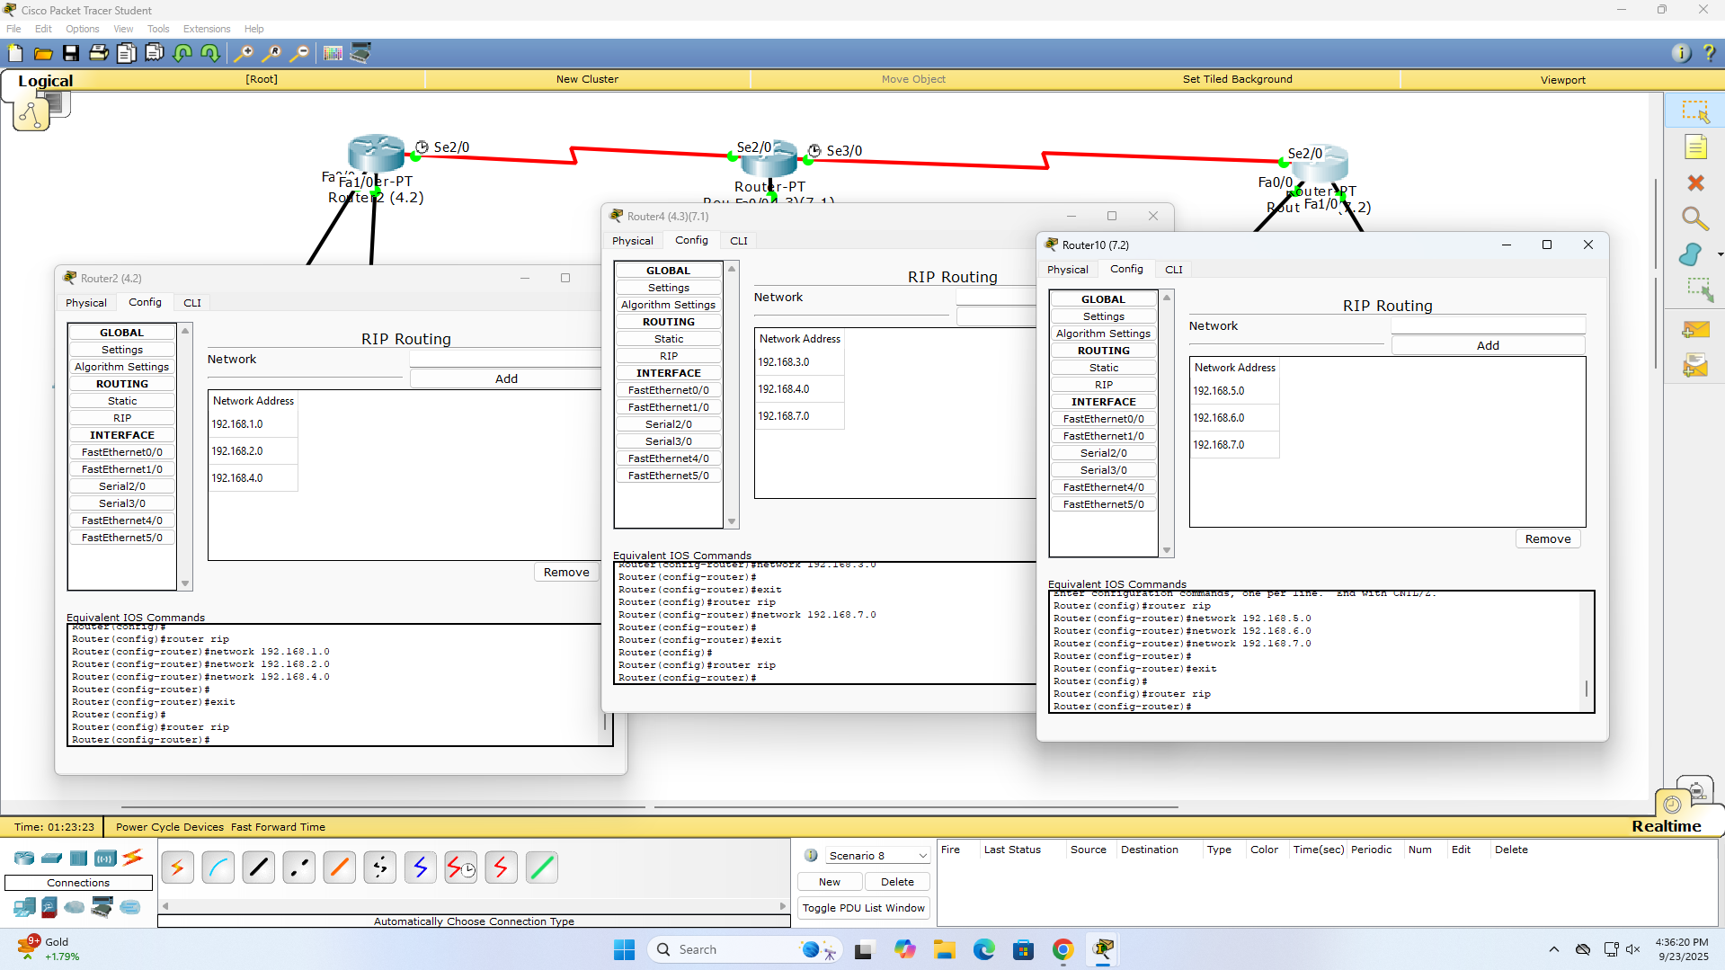

**Observation:**

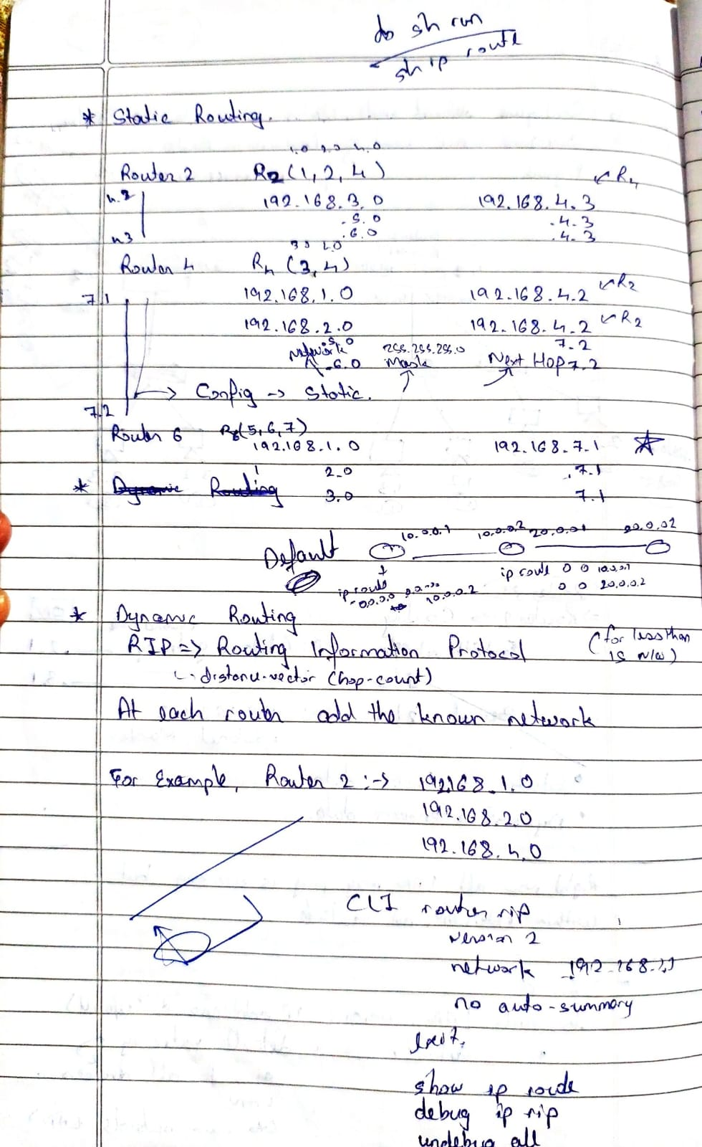

**Program 7**

**Aim:** Configure OSPF routing protocol

**Topology:**

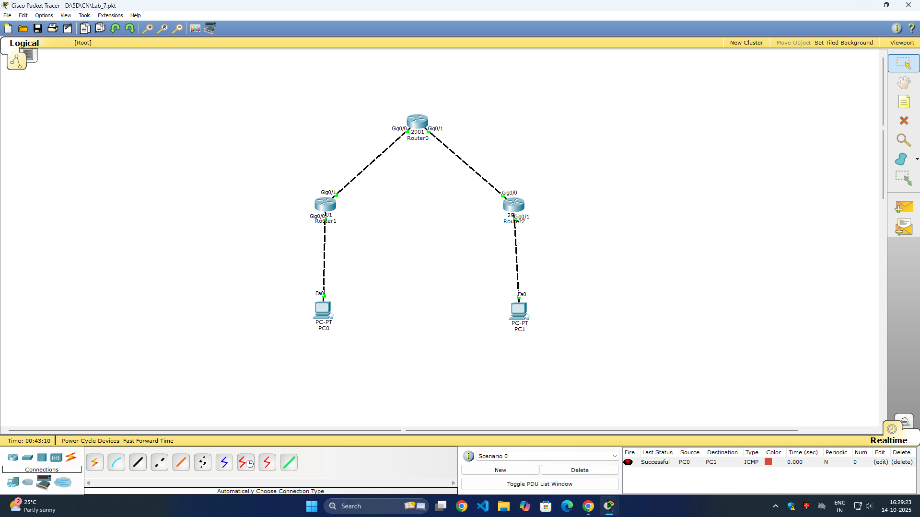

**Procedure:**

Router> enable

Router# conf t

Router1(config)# router ospf 1

Router1(config-router)# network 192.168.44.0 0.0.0.255 area 0

Router1(config-router)# exit

Router1(config)# exit

Router1# write memory

**Output:**

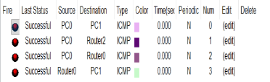

**Observation:**

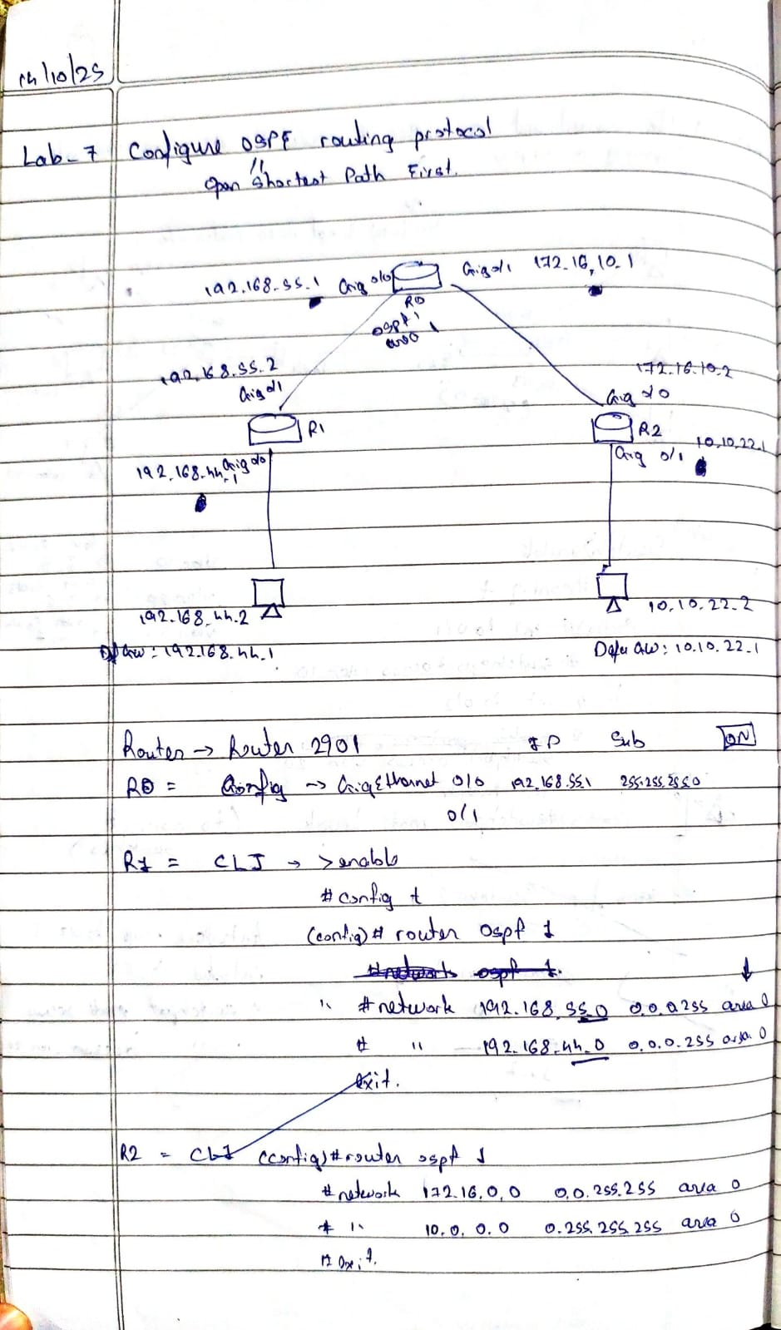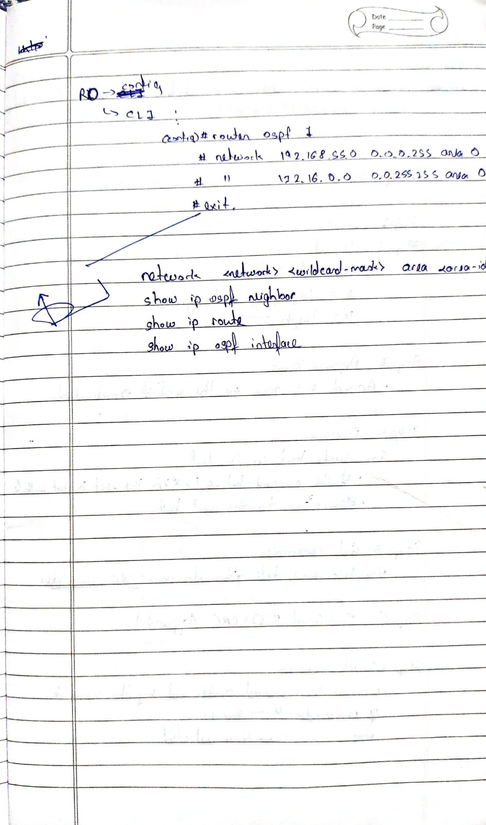

**Program 8**

**Aim:** Demonstrate the TTL/ Life of a Packet

**Topology:**

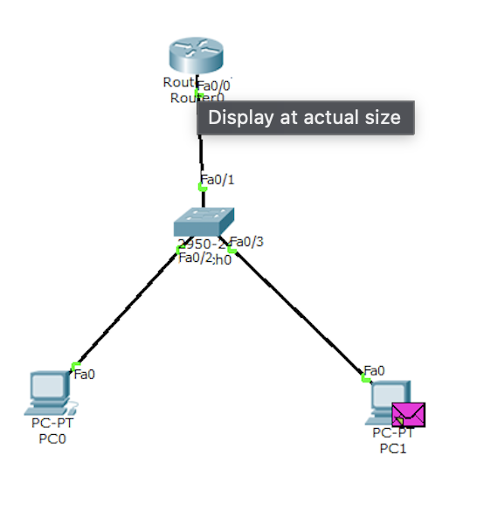

**Procedure:**

1. Enable Packet Capture:
   * Right-click on a link between devices
   * Select "Capture / Forward"
   * Send ping from PC19 to PC20
2. Analyze TTL in Captured Packets:
   * Open "Event List" in Simulation mode
   * Double-click any ICMP packet
   * Go to "Inbound PDU Details" or "Outbound PDU Details"
   * Check "IP" section → "Time to Live" field

**Output:**

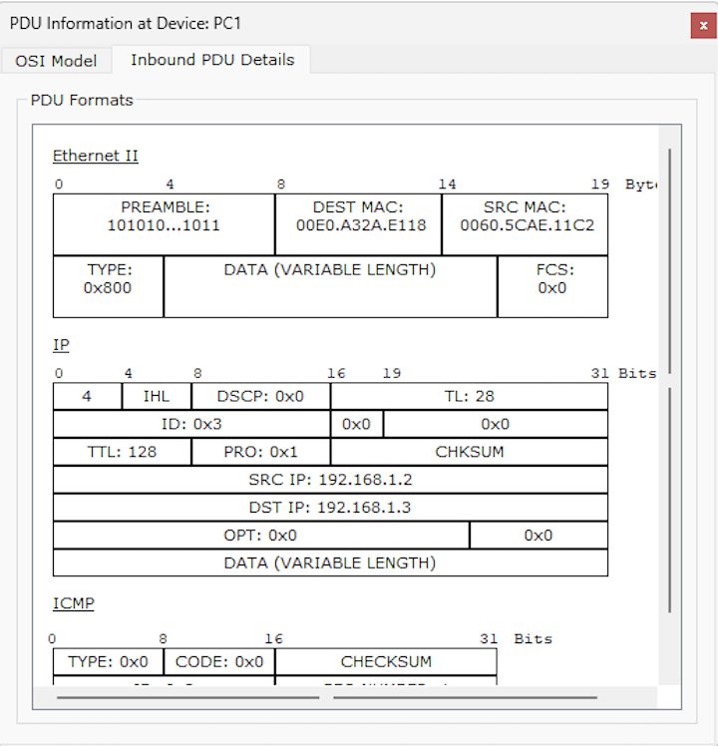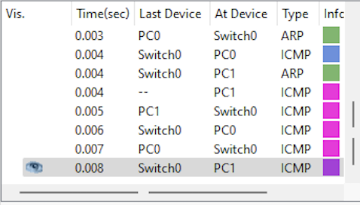

**Observation:**

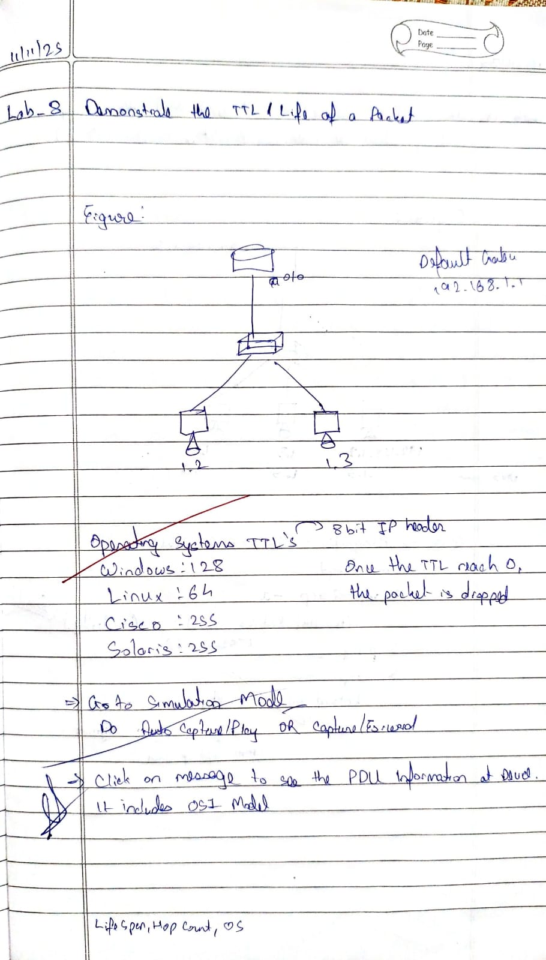

**Program 9**

**Aim:** To construct a VLAN and make the PC’s communicate among a VLAN

**Topology:**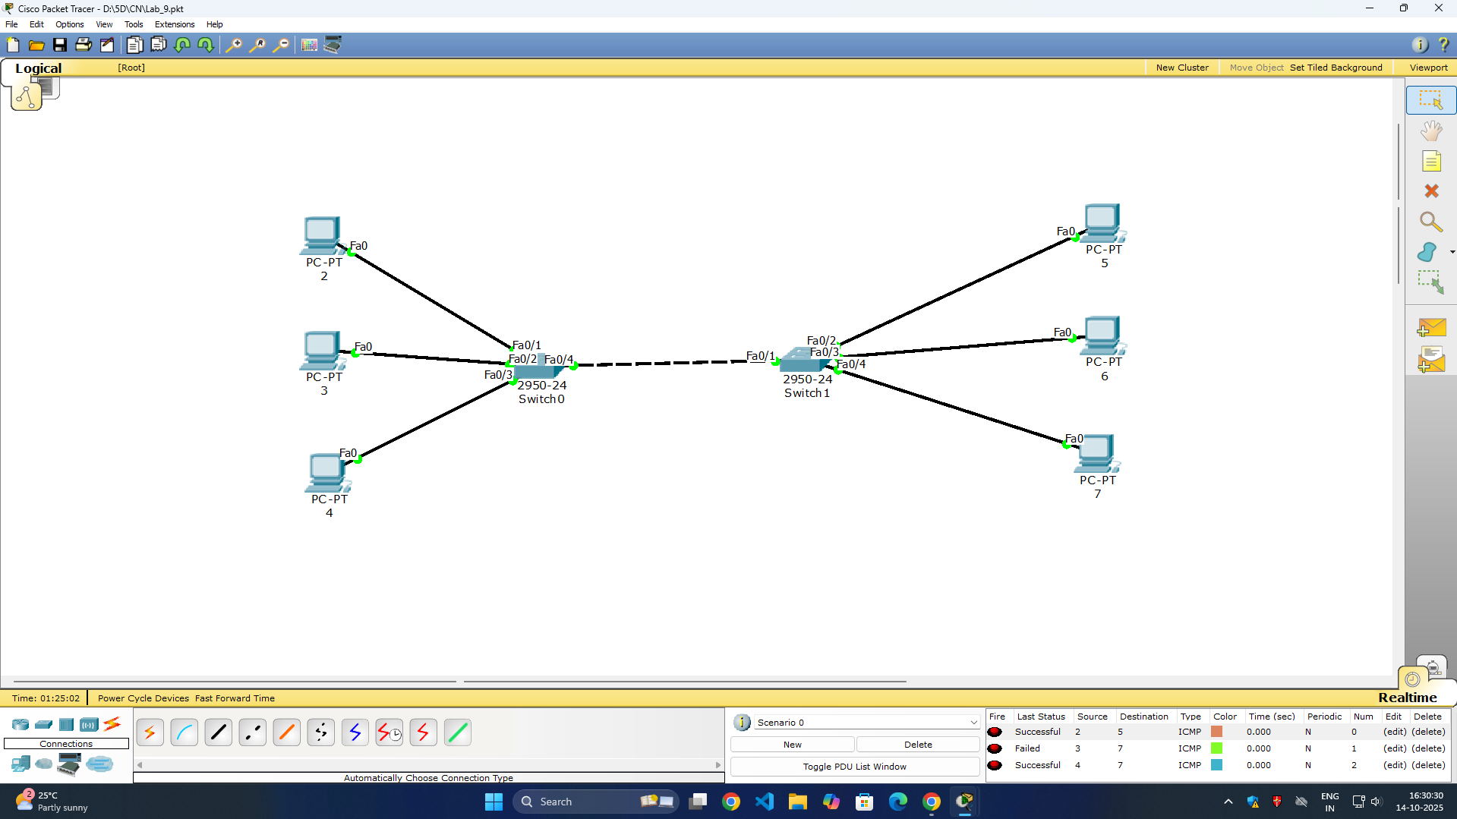

**Procedure:**

Switch> enable

Switch# configure terminal

Switch(config)# interface fastethernet 0/1

Switch(config-if)# switchport mode access

Switch(config-if)# switchport access vlan 10

Switch(config-if)# no shutdown

Switch(config-if)# exit

Switch(config)# interface fastethernet 0/2

Switch(config-if)# switchport mode access

Switch(config-if)# switchport access vlan 10

Switch(config-if)# no shutdown

Switch(config-if)# exit

Switch(config)# interface fastethernet 0/4

Switch(config-if)# switchport mode trunk

Switch(config-if)# no shutdown

Switch(config-if)# exit

Switch(config)# exit

Switch# write memory

**Output:**

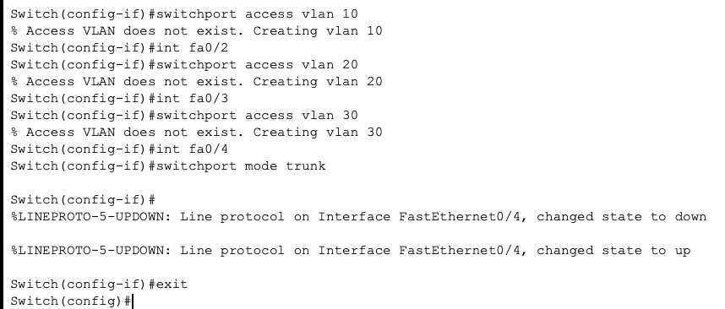

**Observation:**

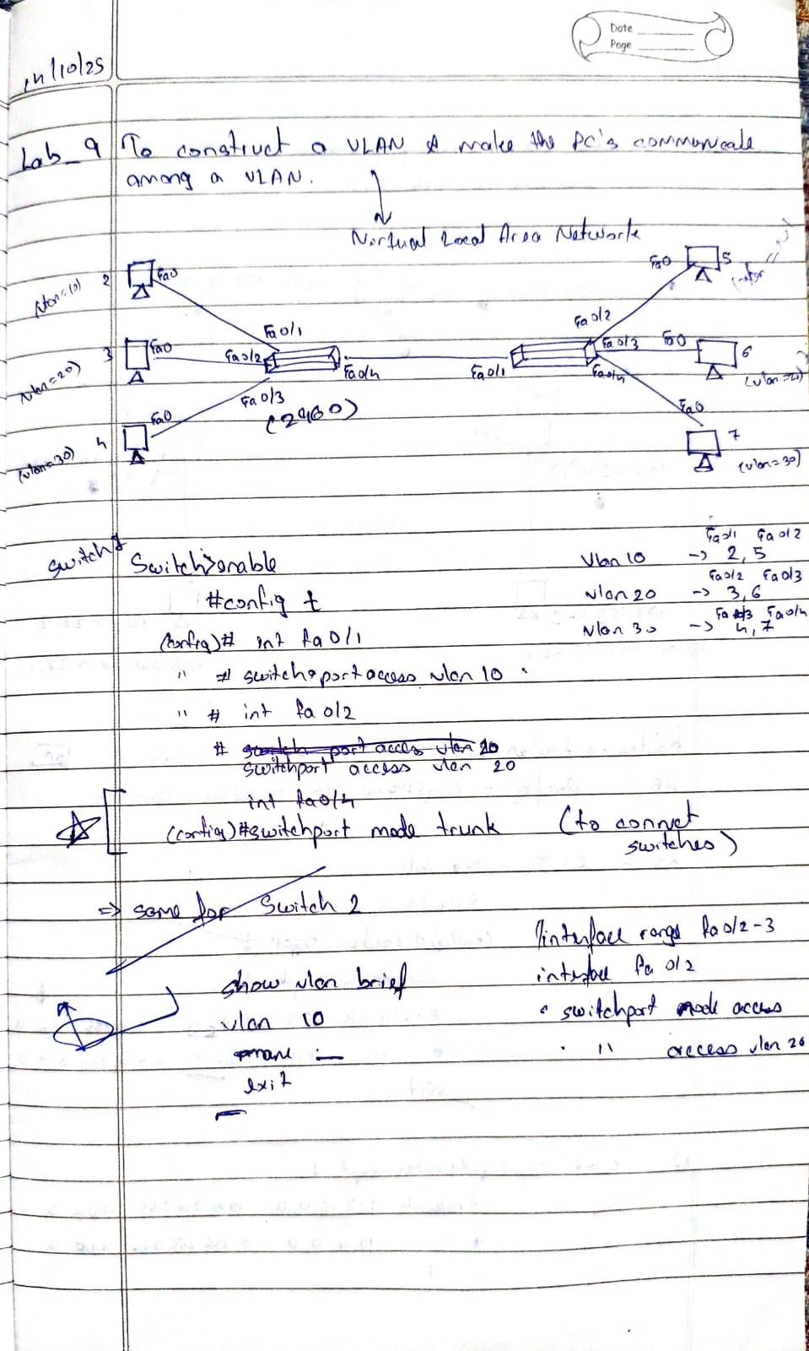

**Program 10**

**Aim:** To construct a WLAN and make the nodes communicate wirelessly  
**Topology:**

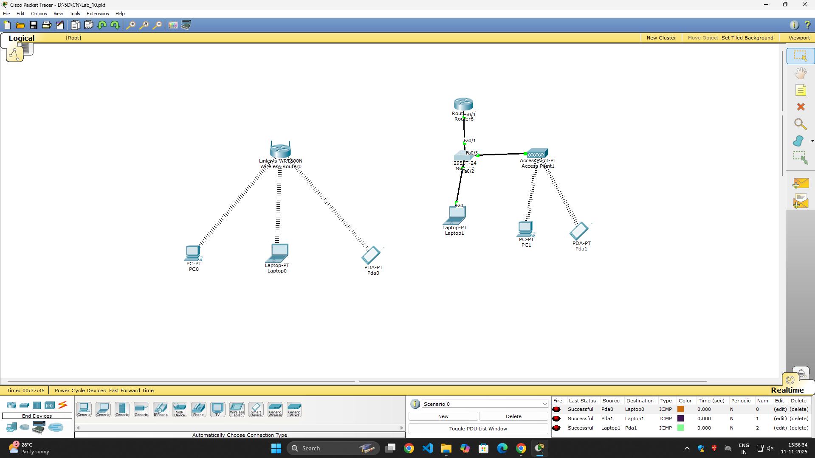

**Output:**

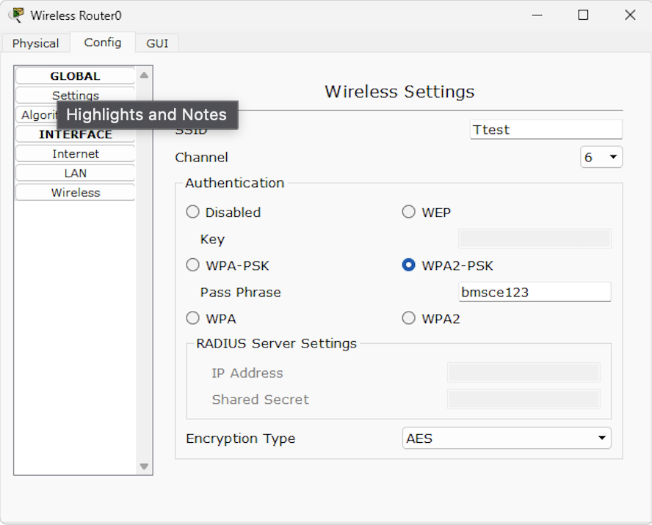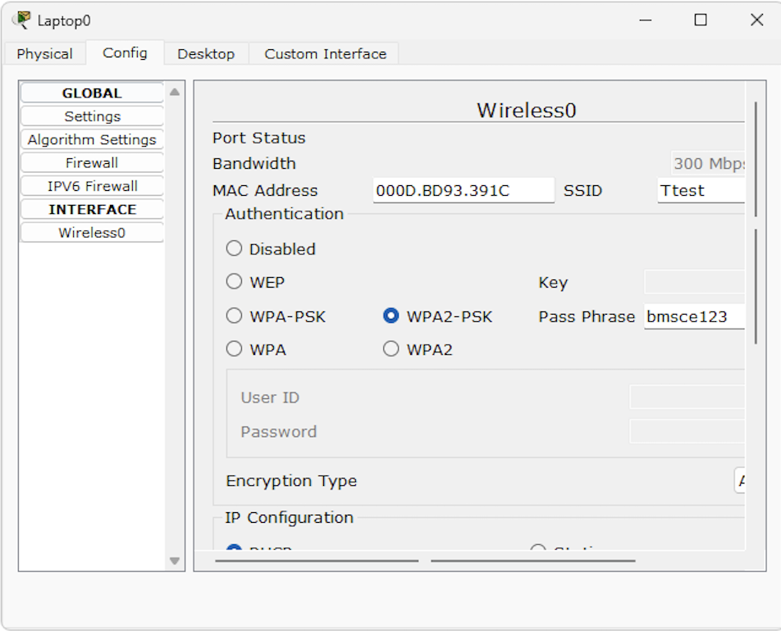

**Observation:**

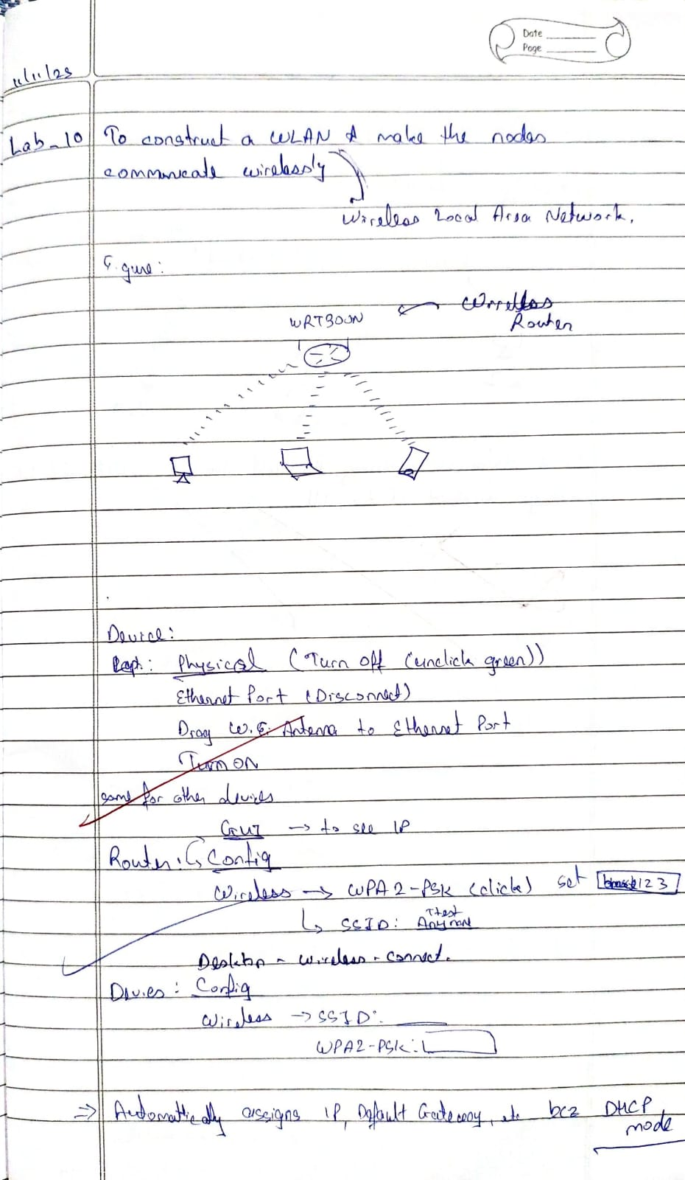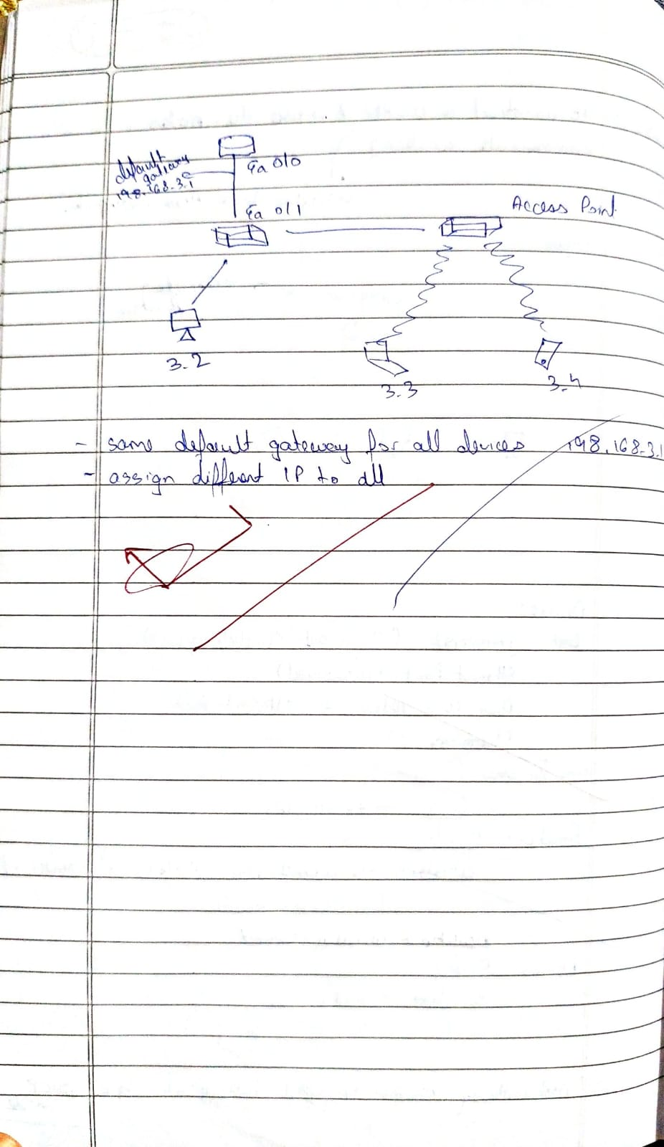

**Program 11**

**Aim:** To construct simple LAN and understand the concept and operation of Address Resolution Protocol (ARP)

**Topology:**

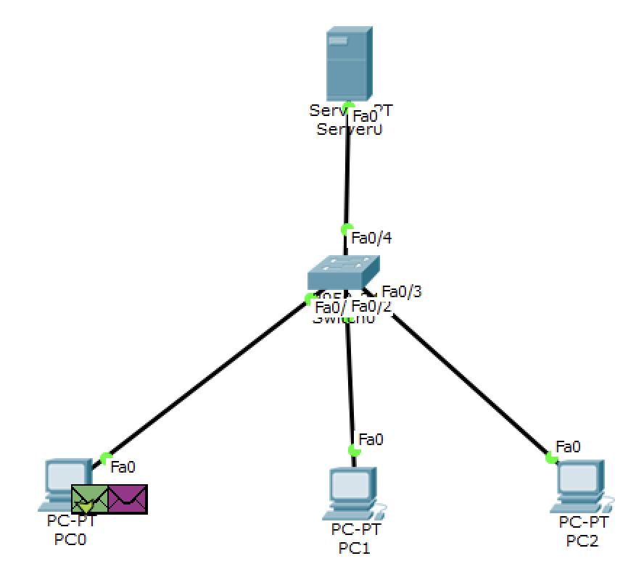

**Procedure:**

ping 192.168.1.20

arp -a

Interface: 192.168.1.10

Internet Address Physical Address Type

192.168.1.20 00-50-56-xx-xx-xx dynamic

192.168.1.30 00-50-56-yy-yy-yy dynamic

**Output:**

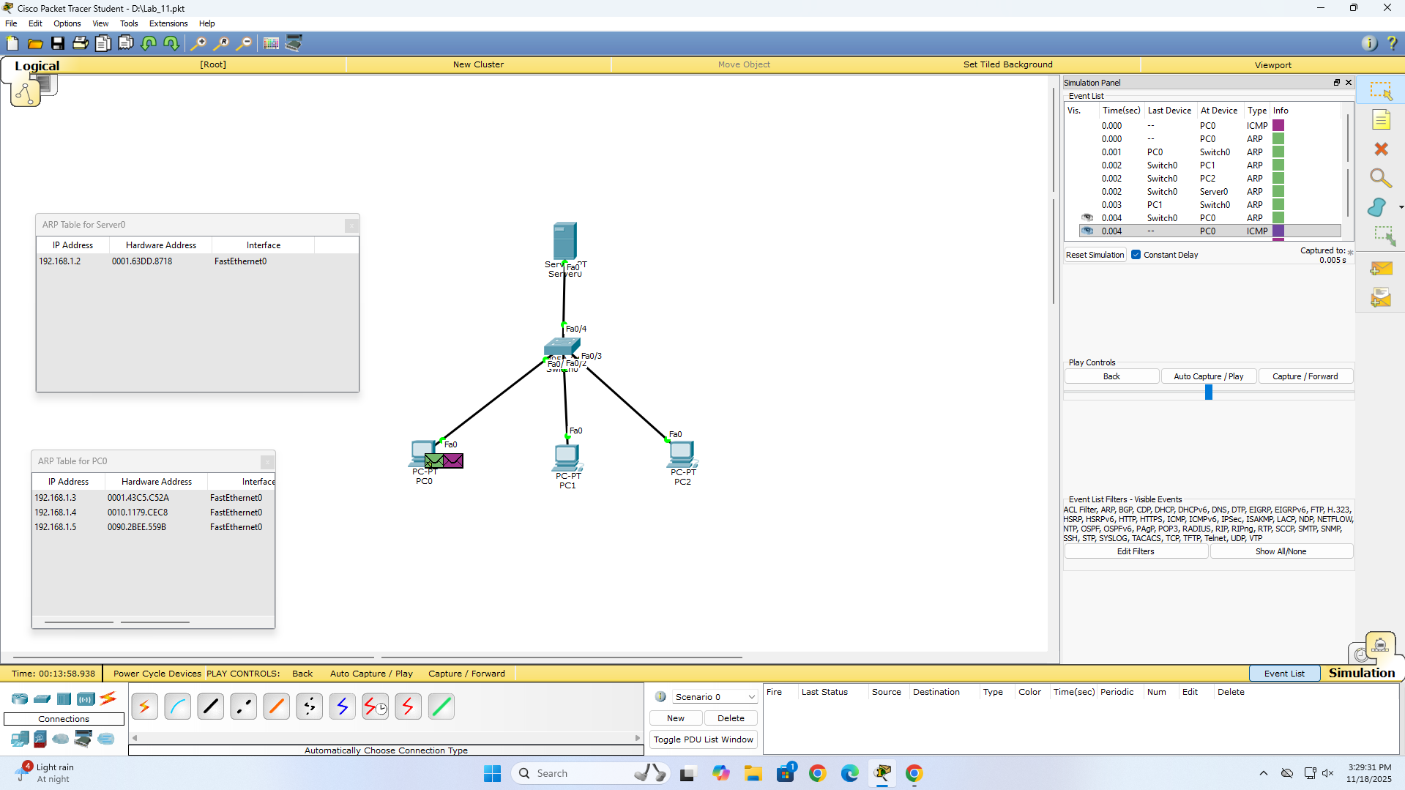

**Observation:**

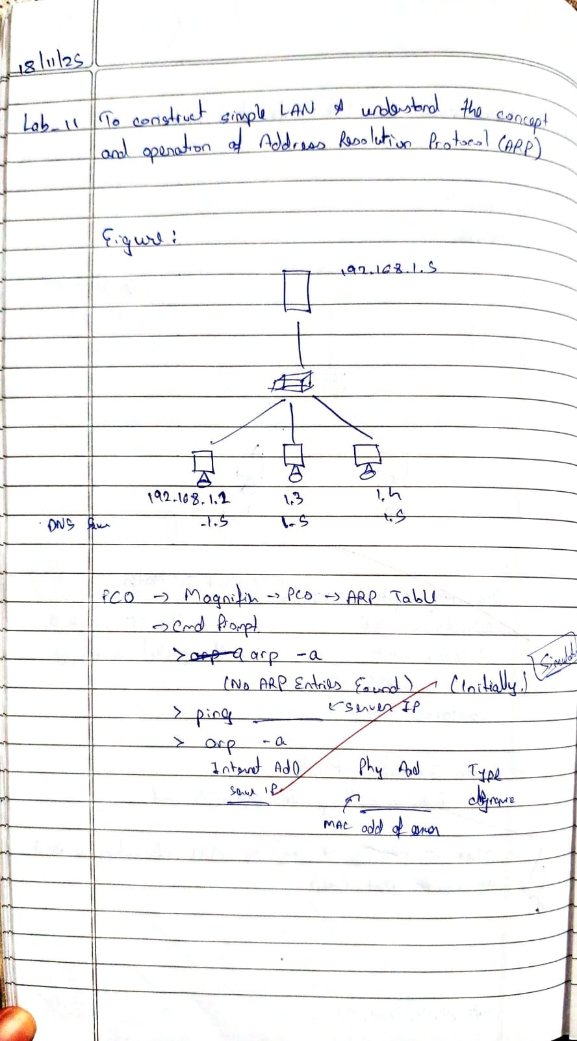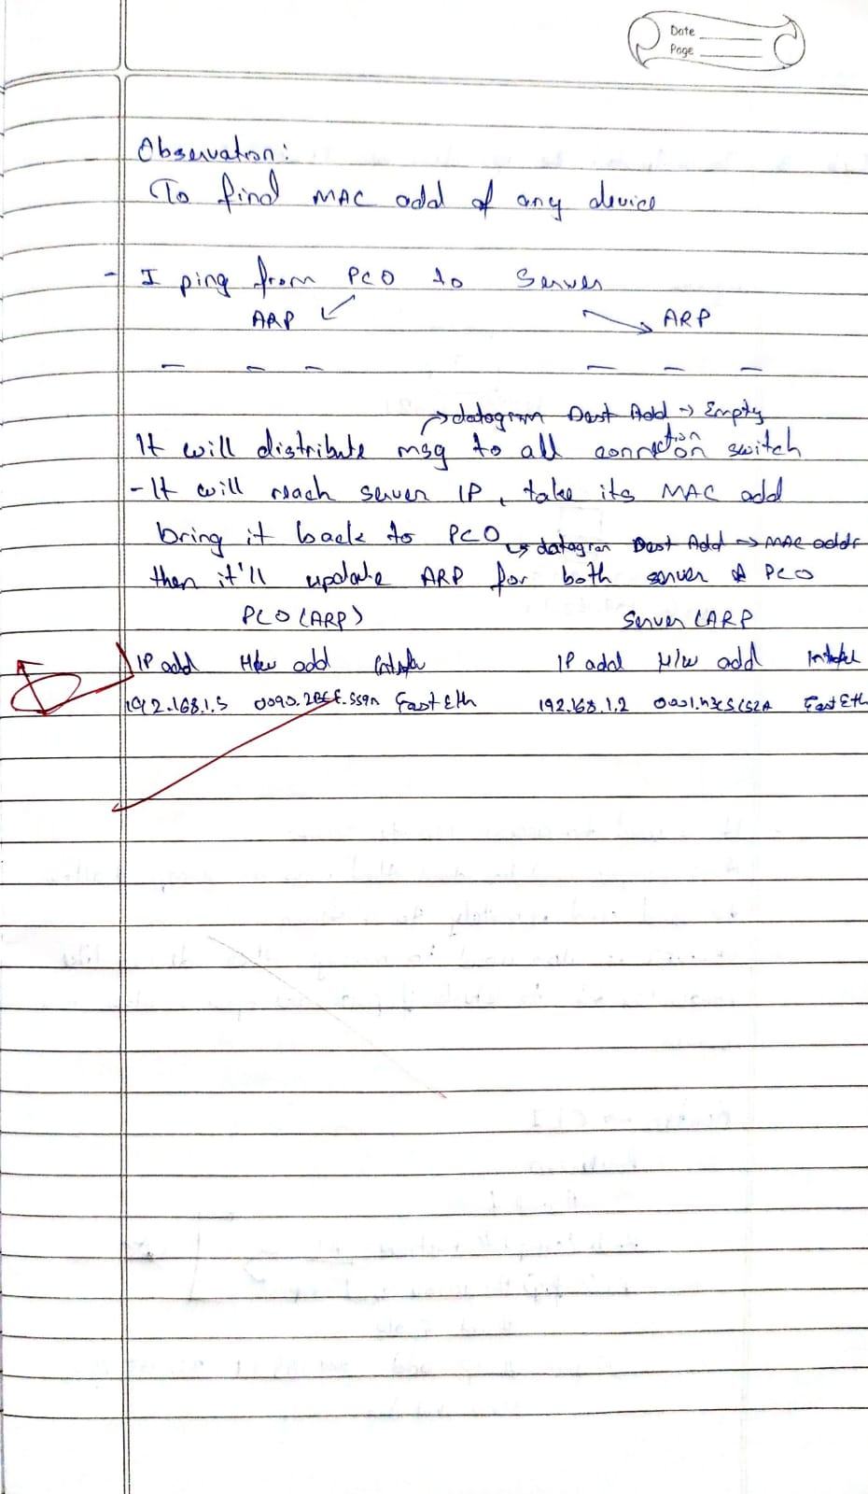

**Program 12**

**Aim:** Create a topology and simulate sending a simple PDU from source to destination using hub and switch as connecting devices and demonstrate ping message.  
**Topology:**



**Output:**

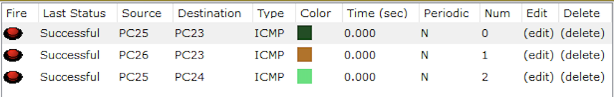

**Observation:**

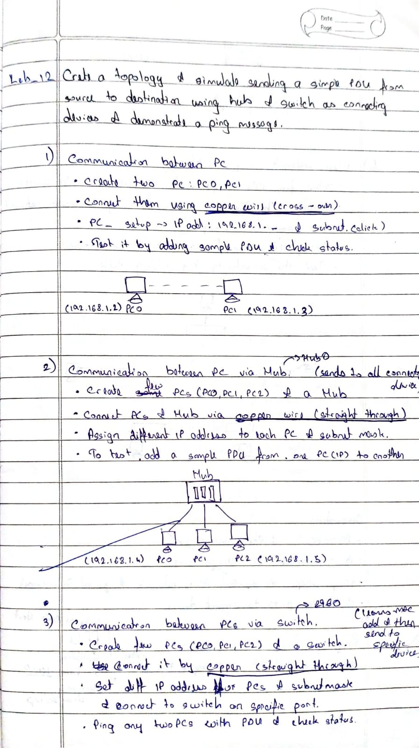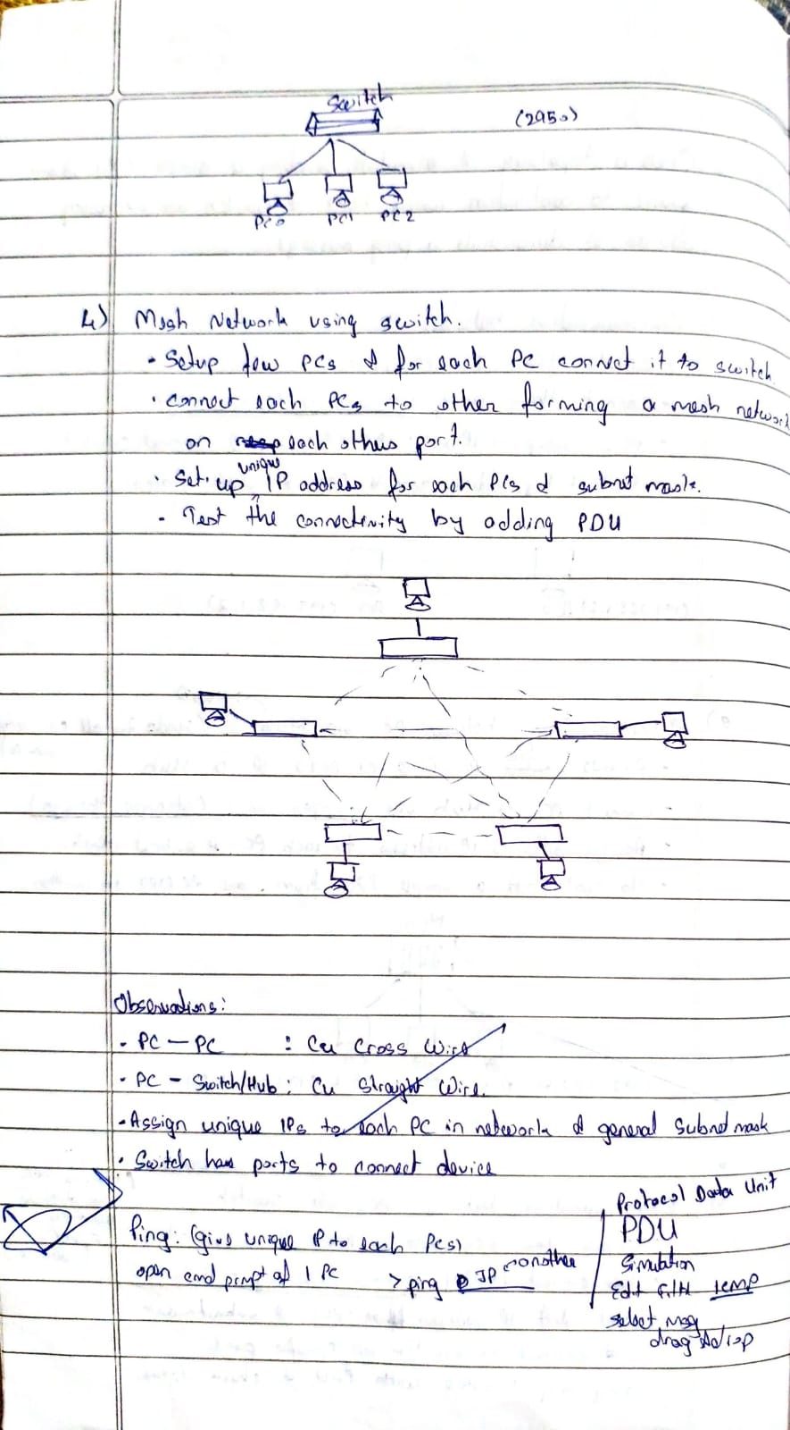

**Program 14**

**Aim:** Write a program for congestion control using Leaky bucket algorithm.

**Code:**

#include <stdio.h>

int min(int x, int y) {

if (x < y)

return x;

else

return y;

}

int main() {

int drop = 0, mini, nsec, cap, count = 0, i, inp[25], process;

printf("Enter the bucket size:\n");

scanf("%d", &cap);

printf("Enter the processing rate:\n");

scanf("%d", &process);

printf("Enter the number of seconds you want to simulate:\n");

scanf("%d", &nsec);

for (i = 0; i < nsec; i++) {

printf("Enter the size of the packet entering at %d sec:\n", i + 1);

scanf("%d", &inp[i]);

}

printf("\nSecond | Packet Received | Packet Sent | Packet Left | Dropped\n");

printf("--------------------------------------------------------------\n");

for (i = 0; i < nsec; i++) {

count += inp[i];

if (count > cap) {

drop = count - cap;

count = cap;

}

printf("%d\t %d\t\t", i + 1, inp[i]);

mini = min(count, process);

printf("%d\t\t", mini);

count = count - mini;

printf("%d\t\t %d\n", count, drop);

drop = 0;

}

for (; count != 0; i++) {

if (count > cap) {

drop = count - cap;

count = cap;

}

printf("%d\t 0\t\t", i + 1);

mini = min(count, process);

printf("%d\t\t", mini);

count = count - mini;

printf("%d\t\t %d\n", count, drop);

drop = 0;

}

return 0;

}

**Output:**

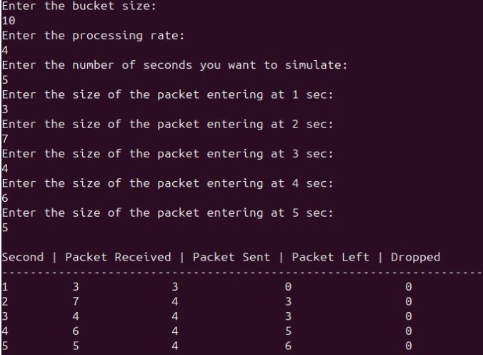

**Observation:**

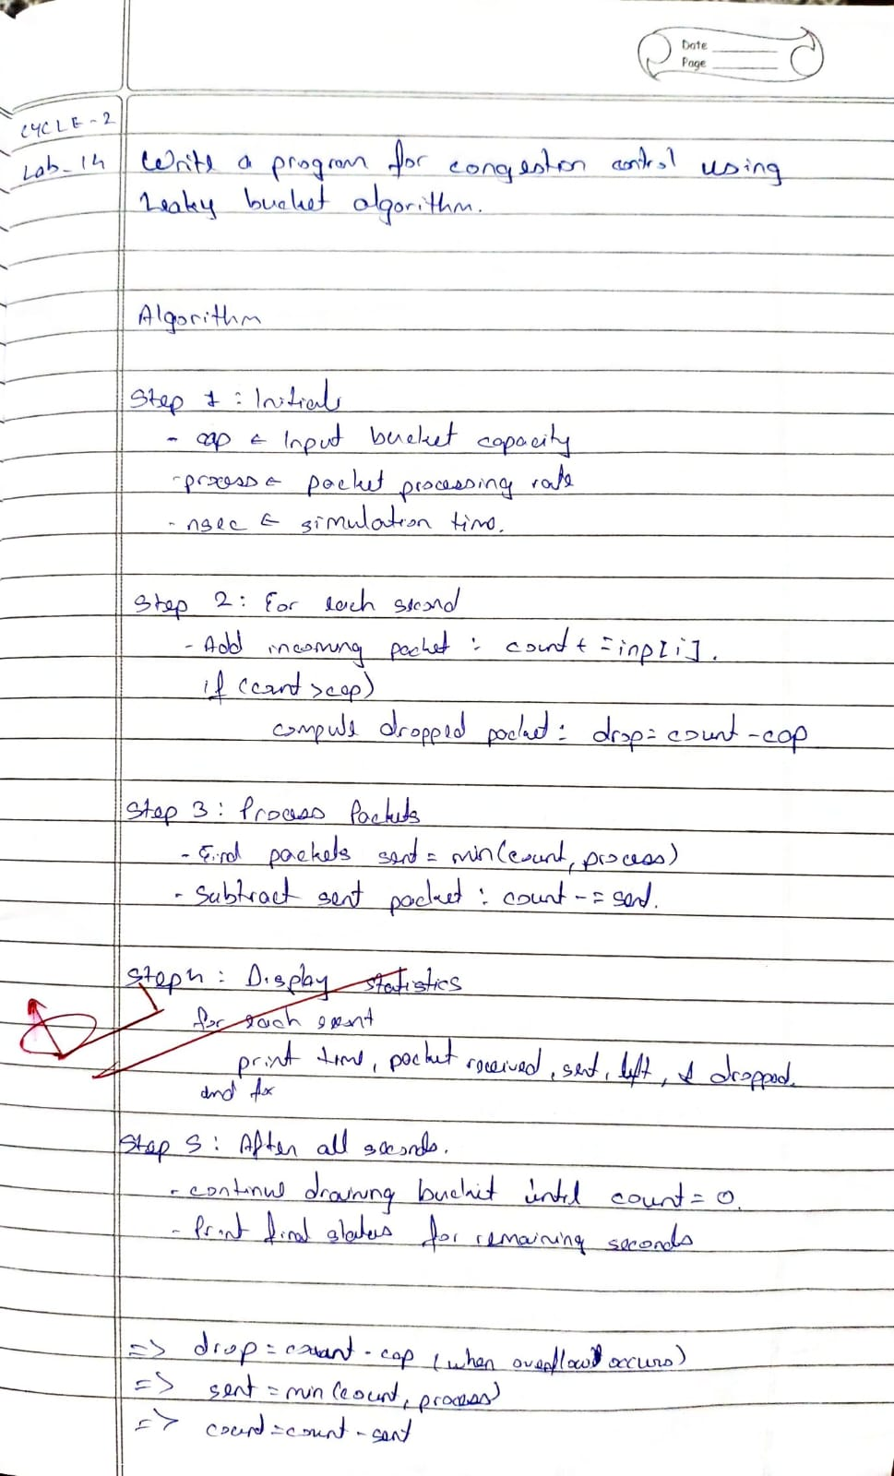

**Program 15**

**Aim:** Using TCP/IP sockets, write a client-server program to make client sending the file name and the server to send back the contents of the requested file if present.

**Algorithm:**

| # tcp_client.py  import socket  # Step 1: Create TCP socket  client_socket = socket.socket(socket.AF_INET, socket.SOCK_STREAM)  # Step 2: Connect to server  client_socket.connect(('localhost', 8080))  # Step 3: Send filename  filename = input("Enter filename to request: ")  client_socket.send(filename.encode())  # Step 4: Receive file contents  data = client_socket.recv(4096).decode()  print("\n--- File Content ---\n") print(data  # Step 5: Close connection client_socket.close() | # tcp_server.py import socket  # Step 1: Create a TCP socket server_socket = socket.socket(socket.AF_INET, socket.SOCK_STREAM)  # Step 2: Bind to address and port server_socket.bind(('localhost', 8080))  # Step 3: Listen for client connections server_socket.listen(1) print("Server is listening on port 8080...")  # Step 4: Accept connection  conn, addr = server_socket.accept() print("Connected by:", addr)  # Step 5: Receive file name filename = conn.recv(1024).decode().strip()  try:  # Step 6: Open and read file with open(filename, 'r') as f:  data = f.read()  conn.send(data.encode()) # Send file contents  except FileNotFoundError: conn.send(b"File not found on  server.")  # Step 7: Close connection conn.close() server_socket.close() |
| --- | --- |

**Output:**

**Observation:**

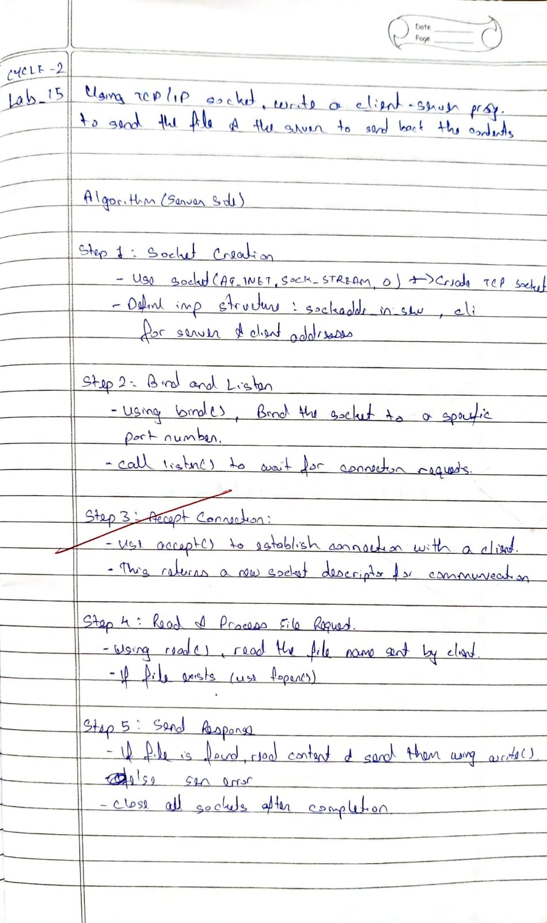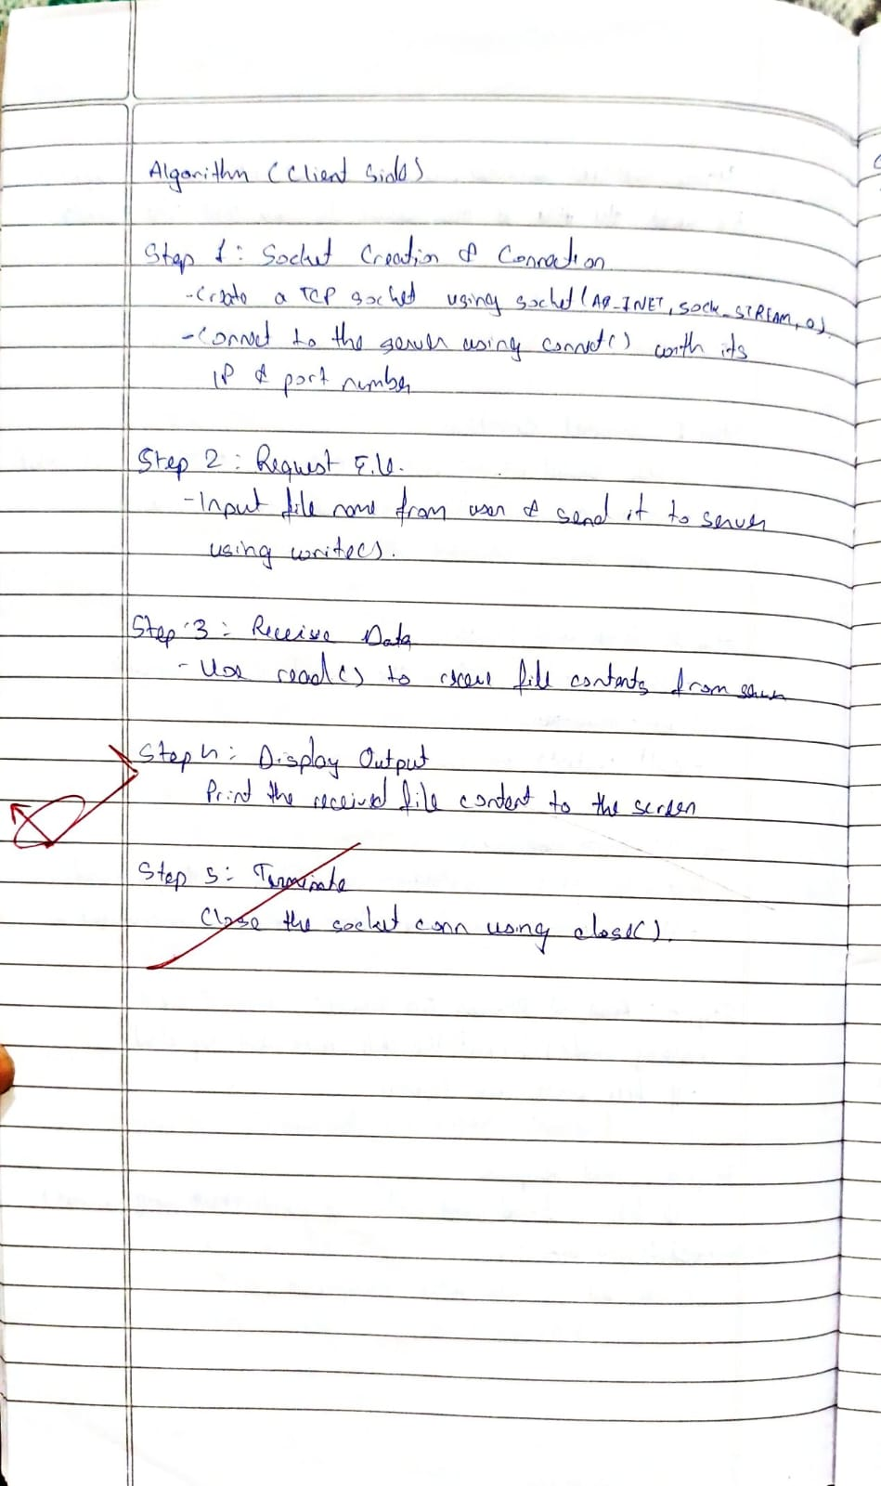

**Program 16**

**Aim:** Using UDP sockets, write a client-server program to make client sending the file name and the server to send back the contents of the requested file if present.

**Algorithm:**

| # tcp_client.py  import socket  # Step 1: Create TCP socket  client_socket = socket.socket(socket.AF_INET, socket.SOCK_STREAM)  # Step 2: Connect to server  client_socket.connect(('localhost', 8080))  # Step 3: Send filename  filename = input("Enter filename to request: ")  client_socket.send(filename.encode())  # Step 4: Receive file contents  data = client_socket.recv(4096).decode()  print("\n--- File Content ---\n") print(data  # Step 5: Close connection client_socket.close() | # tcp_server.py import socket  # Step 1: Create a TCP socket server_socket = socket.socket(socket.AF_INET, socket.SOCK_STREAM)  # Step 2: Bind to address and port server_socket.bind(('localhost', 8080))  # Step 3: Listen for client connections server_socket.listen(1) print("Server is listening on port 8080...")  # Step 4: Accept connection  conn, addr = server_socket.accept() print("Connected by:", addr)  # Step 5: Receive file name filename = conn.recv(1024).decode().strip()  try:  # Step 6: Open and read file with open(filename, 'r') as f:  data = f.read()  conn.send(data.encode()) # Send file contents  except FileNotFoundError: conn.send(b"File not found on  server.")  # Step 7: Close connection conn.close() server_socket.close() |
| --- | --- |

**Observation:**

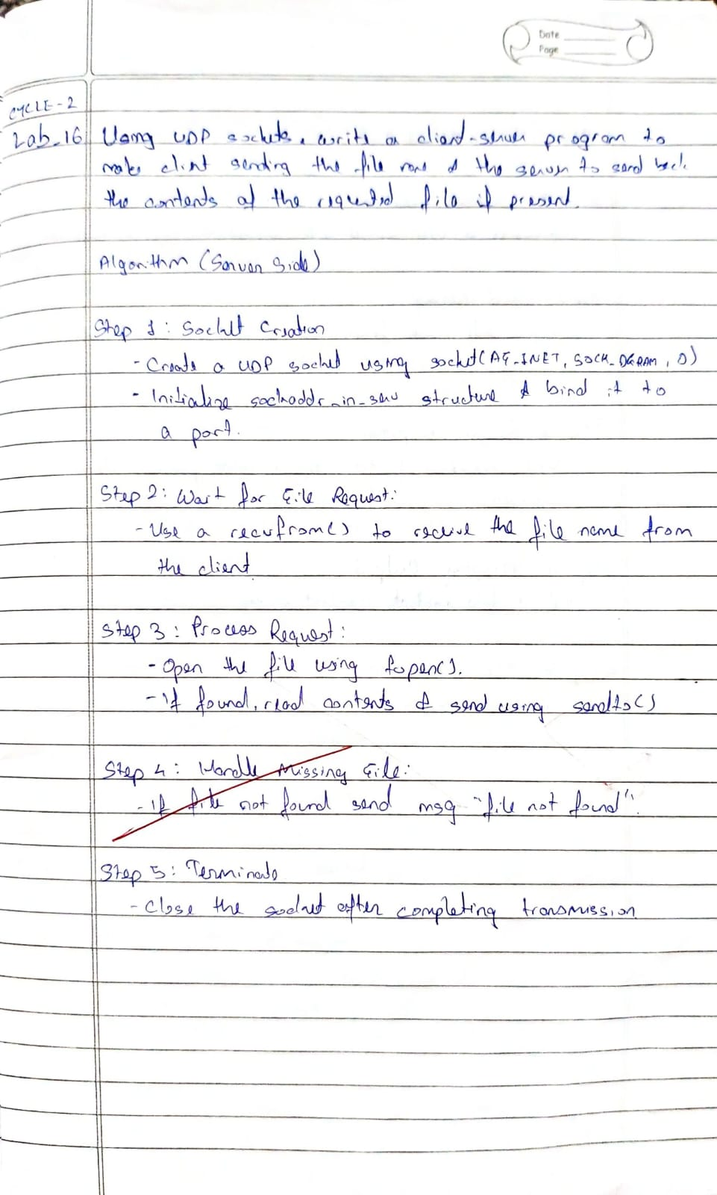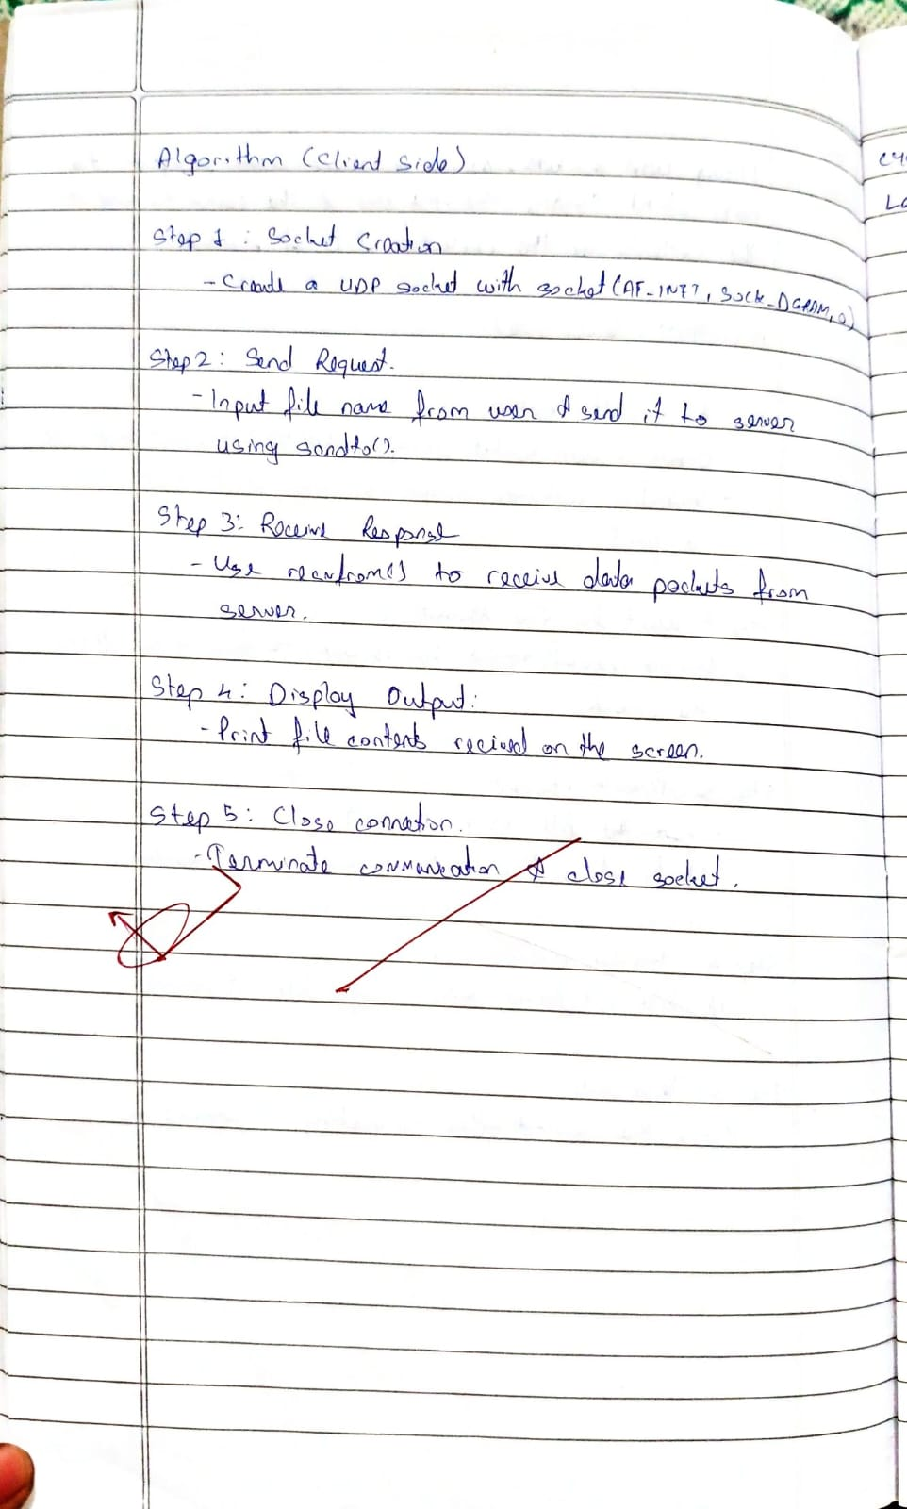

**Program 17**

**Aim:** Write a program for error detecting code using CRC-CCITT (16-bits).

**Code:**

#include <stdio.h>

#include <string.h>

#include <stdlib.h>

int main() {

char rem[50], a[50], s[50], c, msj[50], gen[30];

int i, genlen, t, j, flag = 0, k, n;

printf("Enter the generation polynomial:\n");

gets(gen);

printf("Generator polynomial is CRC-CCITT: %s\n", gen);

genlen = strlen(gen);

k = genlen - 1;

printf("Enter the message:\n");

n = 0;

while ((c = getchar()) != '\n') {

msj[n] = c;

n++;

}

msj[n] = '\0';

for (i = 0; i < n; i++)

a[i] = msj[i];

for (i = 0; i < k; i++)

a[n + i] = '0';

a[n + k] = '\0';

printf("\nMessage polynomial appended with zeros:\n");

puts(a);

for (i = 0; i < n; i++) {

if (a[i] == '1') {

t = i;

for (j = 0; j <= k; j++) {

if (a[t] == gen[j])

a[t] = '0';

else

a[t] = '1';

t++;

}

}

}

for (i = 0; i < k; i++)

rem[i] = a[n + i];

rem[k] = '\0';

printf("Checksum (remainder):\n");

puts(rem);

printf("\nMessage with checksum appended:\n");

for (i = 0; i < n; i++)

a[i] = msj[i];

for (i = 0; i < k; i++)

a[n + i] = rem[i];

a[n + k] = '\0';

puts(a);

n = 0;

printf("Enter the received message:\n");

while ((c = getchar()) != '\n') {

s[n] = c;

n++;

}

s[n] = '\0';

for (i = 0; i < n; i++) {

if (s[i] == '1') {

t = i;

for (j = 0; j <= k; j++, t++) {

if (s[t] == gen[j])

s[t] = '0';

else

s[t] = '1'; }

}

}

for (i = 0; i < k; i++)

rem[i] = s[n + i];

rem[k] = '\0';

for (i = 0; i < k; i++) {

if (rem[i] == '1')

flag = 1;

}

if (flag == 0)

printf("Received polynomial is error-free \n");

else

printf("Received polynomial contains error \n");

return 0;

}

**Output:**

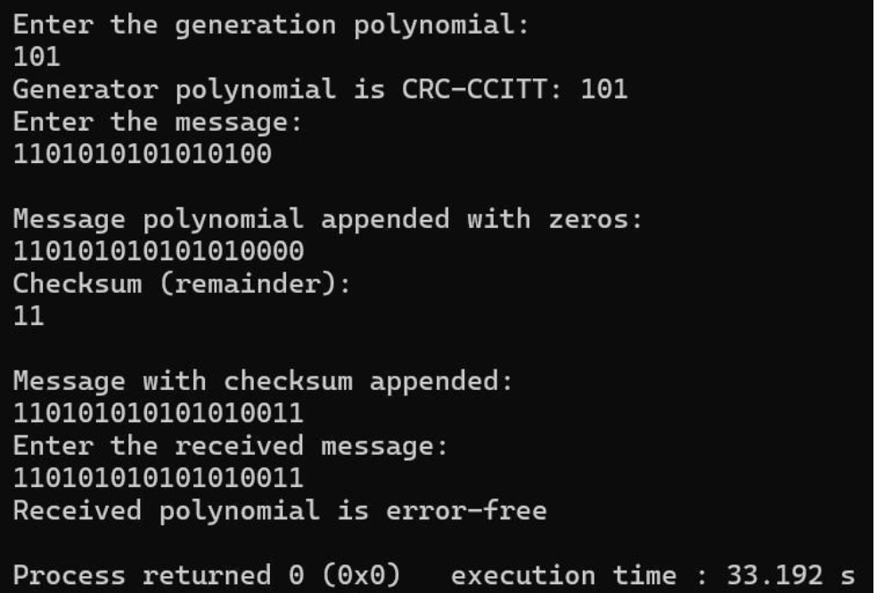

**Observation:**

